

Prof Louise Ryan, Prof María López and Alessia Dalceggio, with Farzana Adell and Mohammad Ibrahim Muzamil
London Metropolitan University
March 2026
Commissioned by the NRPF, Refugee and Migrant Service
An evaluation of the Afghan and Syrian resettlement programmes in the London borough of Islington


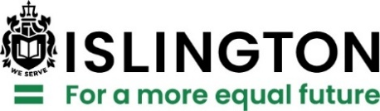

Foreword

As an Islington councillor, I vividly remember those first chaotic days in autumn 2021 following the fall of the Afghan government, the evacuation of Kabul’s airport and the opening of a bridging hotel in the borough. Hardly any information was available, and it was unclear who would be arriving, what support would be required or how long families would be staying. This would require an emergency response to a crisis situation.
Islington has always been a place of welcome to those arriving by choice or by hardship. Indeed, over 40% of our residents were born outside of the UK and have since made Islington their home. It was in that spirit of welcome that we – as a council and as a community – committed ourselves to welcoming the arriving Afghan families.
Islington Council’s NRPF, Refugee and Migrant Service, stepped into this space alongside other council and community partners. The service had expertise in responding to humanitarian crises, having welcomed 18 Syrian families in 2015 and implemented the ‘Everyone In’ housing response to the pandemic in 2020. I am grateful for their depth of knowledge, passion and dedication to support new residents in the borough. Soon, we were learning the stories of these new residents: evacuated British citizens and their Afghan families, unaccompanied children, interpreters, soldiers, journalists, judges and government workers. Together, we listened to individual hopes and dreams for the future, drafted support plans, commissioned specialist services and began moving families out of the hotel.
Remarkably, Islington’s Afghan bridging hotel was one of the first to close, and I am proud that we rehoused two-thirds of the residents within the borough. As these initial families became a part of their local communities by volunteering in schools, setting up stalls in Chapel Market, attending English language classes and making friends in their neighbourhoods, little did we know just how this emergency response would grow to become such an integral part of the work we do as a council. Since our initial commitment to welcome 35 families in 2021, we have supported nearly 200 families via central government-funded resettlement routes, and Islington has become a leader nationally in this area of work.
Amidst this growth, we have not rested on our laurels; we have continued to strive to improve services for newly arrived residents as well as existing ones. In 2023, we formalised our commitment to be a welcoming place for those seeking sanctuary by becoming an accredited Borough of Sanctuary. During recent periods of national uncertainty, we have prioritised local connections and community cohesion so that all Islington residents feel safe and welcome. And if you are reading this report, you will see that we also commissioned London Metropolitan University to evaluate our programme and track our new residents’ progress over time.
This report has been an illuminating way for us to learn more about the residents we support, document the ways in which the council has improved services over time and evidence why this work matters. In it, you will read about one woman who held a pen for the first time in her life while attending an Islington English class. You will learn about another who secured employment at a local charity. I was especially pleased to read about families who have now been reunited after being separated during the initial evacuation. These are the stories of the people who make up the richly diverse borough of Islington that so many of us call home. Seeing their voices in this report makes me proud to serve our community and energises me to continue working towards a more equal future for all.
Even so, there is always more to be done. I hope that partners and central government will join the council in seriously engaging with the recommendations in the report. As a council, we will continue to listen to the needs and hopes of all our residents and to use our influence to push for funding and policies that promote welcome and belonging.
Councillor Sheila Chapman
Executive Member for Equalities, Communities and Inclusion
Islington Council

Acknowledgments

We would like to express our gratitude to all Afghan and Syrian participants, who so generously gave their time for this project and who shared their experiences and stories with us.
We sincerely thank our partners at Islington Council’s Resettlement Team and the collaborators from other departments and organisations for the cooperation and support in the course of this evaluation.
We also wish to express a special thank you to colleagues at Manor Gardens and at the Kurdish Middle Eastern Women Organisation (KMEWO) for welcoming us in their offices and helping us organise in-person interviews and focus groups.

Contents

Foreword 1
Acknowledgments 3
Executive summary 6
1. Introduction 19
1.1. About the study 19
1.2. Aims of the evaluation 19
2. Context of the research 20
2.1. Resettlement schemes 20
2.2. Resettlement in Islington 22
2.2.1. Resettled refugees in Islington 22
2.2.2. Timeline of Islington resettlement programmes 24
3. Methods and ethics 27
3.1. Desk research 28
3.2. Interviews and qualitative data analysis 28
3.3. Stakeholder interviews 28
3.4. Syrian and Afghan residents' interviews 29
3.5. Participants sample description 30
4. Findings 31
4.1. Islington Resettlement provision 31
4.1.1. NRPF, Refugee and Migrant Service 31
4.1.2. Islington Resettlement Team and partners 33
4.1.3. Overview of internal and external partners and their services 38
4.1.4. Overall stakeholder feedback and considerations 42
4.2. Qualitative Analysis (Afghans and Syrians) 47
4.2.1. Housing 47
4.2.2. Cost of Living 50
4.2.3. Employment 52
4.2.4. Language Learning and Proficiency 56
4.2.5. Health and Trauma 60
4.2.6. Schools and Education 64
4.2.7. Social Networks and Making Local Connections 66
4.2.8. End of the Scheme 72
5. Recommendations 75
Appendix 01 79
Appendix 02 82
Appendix 03 85
Appendix 04 86
Appendix 05 87
Appendix 06 90

Executive summary

Introduction
This independent evaluation was conducted by a research team from the Global Diversities and Inequalities (GDI) Research Centre, based at London Metropolitan University. The research team was led by Professor Louise Ryan, Director of the GDI Research Centre, and Professor María López, Deputy Director of the GDI Research Centre; the research assistant was Alessia Dalceggio, a PhD student. Additional research assistance was provided by Farzana Adell and Mohammad Ibrahim Muzamil, both Afghan students at London Metropolitan University.
The research was commissioned and funded by Islington Council and designed in partnership with the NRPF Refugee and Migrant Service team at the council. The research was reviewed and approved by London Metropolitan University’s Research Ethics Committee. The project started in January 2023 and was completed in January 2026.
The project’s aim was to evaluate resettlement programmes in the London borough of Islington. The project employed a longitudinal approach to compare experiences of resettlement among Syrians and Afghans in Islington, and track the progress that Afghans made across key indicators over the three years of the research.
Context
Local authorities voluntarily take part in refugee resettlement and there is no mandatory resettlement quota. Islington involvement in resettlement started in 2015 as a small-scale response and since 2021 has developed into a large-scale service, evolving over time as new routes were created and as the council’s experience with resettlement developed further. Afghan Resettlement is fully funded by the UK Government, with local authorities receiving a streamlined integration tariff per person over 3 years to support housing and integration. Islington was awarded Borough of Sanctuary status by City of Sanctuary in 2023. As of January 2026, Islington Council has supported 403 individuals under Afghan Relocation and Assistance Policy (ARAP) and 255 from the Afghan Citizens Resettlement Scheme (ACRS), for a total of 658 individuals across both schemes.
Methods
The research is a multi-method study including desk research (document reviews, analysis of data), 25 semi-structured interviews and 2 focus groups with key stakeholders. Moreover, interviews with 11 Syrian participants and longitudinal methods using follow-up interviews with 29 resettled Afghans were conducted, the latter over three waves from 2023-2025, to create a unique rich source of lived experience narratives. Many of the Afghan residents are coming to the end of their formal support under the Resettlement Scheme and hence these latest interviews provided an opportunity to assess how they plan to navigate their lives in Islington beyond the resettlement scheme.
Key findings: Islington resettlement approach
Afghan resettlement in Islington is delivered in-house by the Resettlement Team, which sits within the NRPF, Refugee and Migrant Service (Homes and Neighbourhoods Directorate). The Resettlement Team is currently composed of 12 members, 5 Refugee Resettlement Officers, 2 Senior Refugee Resettlement Officers, 2 Refugee Resettlement Support Officers, 1 Refugee Resettlement Manager, 1 Refugee Resettlement Housing Lead, and 1 Business Administration Apprentice.
In undertaking our evaluation, we noted how the Resettlement Team expands to include strategic partners in other local authority services, funding 3 specialised roles in iMax (Income Maximisation), 3 in iWork and 2 in Adult Community Learning (ACL). Importantly, we also observed Islington’s partnership approach with external organisations to provide holistic support to resettled families and individuals through collaborative work with external partners, namely the Traumatic Stress Clinic, Brandon Centre and University College London Hospital (UCLH) RESPOND Clinic, as well as with organisations such as the Kurdish and Middle Eastern Women’s Organisation (KMEWO) and the Refugee and Migrant Forum of Essex and London (RAMFEL).
The council has developed a bespoke case management system called Resettlement Connect which provides caseworkers with a birds-eye-view of the support systems and partnerships already in place and helps identify areas for development and improvement. In this system individuals are assigned a red, amber and green rating for each of the integration categories, and one for their overall household. The integration categories are:
- Access to Education
- Employment and Volunteering
- Health and Well-being
- Financial Stability
- Housing
- Immigration
- Local Living
- Safeguarding
Housing support and provision changed significantly between the resettlement of Syrian and Afghan residents. With the development of the Afghan resettlement model, Islington developed a role for a dedicated housing lead which sits across the NRPF Refugee and Migrant Service. Funding from the Greater London Authority (GLA) was expanded further through the Ministry of Housing, Communities and Local Government’s (MHCLG)’s Local Authority Housing Fund (LAHF) to buy back over 400 ex-council homes. Buy-backs are not only assigned to people who fled Afghanistan, but also Ukraine, as well as families and individuals on temporary accommodation waiting lists.
Based on all the interviews and focus groups with the 25 stakeholders, we observed that all services provided beneficial, holistic support to resettled families and individuals. Particularly commendable is the role of the Resettlement Team and their coordination of, support to, and communication with, all partners.
Nonetheless, stakeholders emphasised that in their process of resettlement Afghans are dealing with “a variety of issues and barriers” (S11), as they navigate a new and unfamiliar environment in the UK and complex structural systems. These can result in “lots of stress” and “confusion” (S11) all while dealing with a profound sense of “loss” (S12). Moreover, from this research it is evident that Afghan participants are very diverse, and their needs and circumstances vary considerably. This was also noted by stakeholders, who discussed differential uptake of their services and/or the need to adjust the starting point of support provision on the basis of gender, educational level, professional experience, literacy, age and English proficiency. Hence stakeholders did not operate under a ‘one-size fits all’ type of provision but instead tailored their services to meet specific needs.
What is working well
- Direct line between service providers and Resettlement Team: Partner organisations were very complimentary about the Islington Resettlement Team and highlighted their positive working relationship.
- Ring-fenced/dedicated funding: Organisations and schools reported that specific funding for the development of services for resettled people helped them prioritise and/or dedicate time, personnel and resources to address the needs and issues encountered by Afghans.
- Dedicated, service-specific personnel: Having specific roles for the support of resettled Afghans allowed organisations to build capacity, gain and develop specific skills or knowledge.
- Bespoke approach to individual, intersectional needs: Services developed individualised approaches in working with Afghan individuals and families recognising intersecting, complex circumstances, and differential uptakes of services.
Persistent challenges
- Structural issues: Some of the most challenging aspects of resettlement were related to wider socio-economic and political structural systems, beyond the remit of Islington Council. For example, financial hardship due to the rising cost of living and benefit cuts, the housing crisis, protracted and complex immigration procedures, affected Afghans in their resettlement journey and consequently limited, prevented or unnecessarily complicated the provision of support by services.
- Future funding of the scheme: As the ARAP and ACRS schemes have now been superseded by the Afghan Resettlement Programme (ARP), changing funding instructions may impact on the way resettlement can be managed locally. Funding cuts beyond resettlement were also a challenge, especially when stakeholders collaborated with other specialist organisations, such as immigration providers with no access to legal aid.
Key Findings: Afghans and Syrians longitudinal interviews
I thank wholeheartedly [case worker] because since the beginning he helped us in a lot of issues, not just the procedure, procedural answer with registration or these things, but he motivated me and my family members to look ahead into the long-term prospects of our life, not just making on the short-term gains. So, he has been outstanding (Afghan man).
Housing
- Research participants are grateful to the council for providing them with a secure home; certain challenges persist, especially for larger families, although with the introduction of a greater number of available properties (via LAHF) families’ experience of rehousing has been positively affected.
- Afghans had been unaware of challenges rooted in structural conditions related to the UK housing crisis and rental prices; hence, some initially struggled to adjust to life in London, partly due to their high expectations about housing size and availability. As time went on, their perceptions and expectations aligned more with the reality of living in London and were particularly happy with the efforts of the council in providing more suitable accommodation for their needs.
- While the council has supported families to move to more suitable properties with the introduction of the LAHF programme, rehousing large families still carries logistical challenges and difficulties around housing availability.
Cost of Living
- Afghans are very grateful to be able to access financial support, although as with other residents in London, the higher cost of living in the city poses a considerable challenge. Moreover, their resettlement coincided also with the rise of living costs and the fuel crises in 2021/2022, which also impacted many other UK households.
- For large Afghan and Syrian families, with many children to support, the financial pressures are especially apparent and a worry to parents, especially when affected by the two-child benefit cap.
- Afghans’ future financial security depends upon the opportunity to find well paid employment. However, as indicated below, their experiences of navigating the labour market are quite varied.
Employment
- Findings reveal mixed employment patterns amongst resettled Afghans.
- English language and prior qualifications are key. While some got jobs and are doing well, many struggle to find employment, despite having good skills, because of language.
- Ongoing support with language is crucial to ensure that they can get decent jobs and re-activate their skill sets.
- Many women will also need to work to contribute to the household finances, given high living costs in London. Some women are already working and doing well. Others need more support with language and basic training, especially those with limited prior education in Afghanistan.

Language Learning and Proficiency
I’m also thanking Islington Council that provided for us the programme on Fridays that helps us, that we have learnt a lot the English language from the beginning until now (Afghan woman)
- English language proficiency is not only a significant factor that supports people through their resettlement, education and career re-activation, it is a skill that many participants are eager to learn.
- English proficiency among Afghan and Syrians varies over time. Primary school children and young adults who were highly educated before arriving in the UK tend to pick up the language more quickly. Older generations, particularly men, find it the most challenging. We also noted generational differences in language acquisition amongst Syrians.
- Language emerged as a key contributor to independence, both in terms of participants being able to contact services, addressing their challenges and safely navigating their environment. Thus, continued ESOL provision, and even extended opportunities to enhance participants’ language learning, are immensely important.
- While volunteering and employment opportunities would greatly improve both Afghan and Syrian participants' English, they often require a high level of English proficiency from the outset, leading to a catch-22 situation.
Health and Trauma
- Accessing the right support is having a profoundly positive impact on both physical and mental well-being.
- Signposting to appropriate health care, including psychological counselling is clearly important and necessary even years after people arrive in the UK.
- Some people found technology helpful in accessing GP appointments and prescriptions. However, it can be confusing and ineffective for some, particularly when it comes to tele-consultations with doctors.
- Findings show the profound mental health challenges faced by some displaced people. Several Afghans and Syrians described symptoms of persistent stress, depression and anxiety – manifesting in sleep disorders, for example.
- The accounts shared by some of the Syrian interviewees indicate the long-term consequences of such mental health issues.
Schools and Education
I can go and pick up my kid and just talk to them. It’s very easy. The school... it’s excellent and we are very happy and very proud (Afghan man).
- Overall, families found schools to be welcoming places where teachers were approachable, and their children felt safe and supported.
- Families were satisfied with their children’s primary school education and progress. However, Afghan and Syrian participants often struggled to understand the many options and requirements for progressing through secondary school into further education and university. This was particularly challenging for recently arrived teenagers with limited English skills, as they were expected to join the GCSE year groups. A key issue is that students are placed in year groups according to their age rather than their English proficiency. In some cases, this has caused stress and fear of failure.
Social Networks and Making Local Connections
- Despite feeling safe in London, some people feel lonely. The extent to which they made new friends depended in part on language skills and opportunities to meet people.
- According to some of our interviewees, it should not be assumed that all Afghans – both newcomers and previous waves of migrants – will form a ‘community’ on the basis of their shared national origin.
- Making friends with neighbours seemed to be difficult because of busy lifestyles and lack of common languages as well as perceived cultural differences.
- Young people had opportunities to make new friends through college.
- Organised groups like the Friday women’s group are vital for many Afghan women in forging very close, new friendships. Volunteer befrienders were also very important for some families.
- Family reunion has transformed some networks and participants were very grateful that relatives now live nearby. But wider government policy has now reduced these opportunities. For both Afghans and Syrians, on-going worry about close relatives in dangerous situations can have a severe emotional impact and prevent people from really embedding in the UK.
End of the scheme
Last week the caseworker visited our flat and they said that we are settling in, we can solve some problems ourselves. There is no need of being under the resettlement scheme anymore (Afghan woman)

- The heterogeneity of resettled Afghans is reflected in their varied capacity to adjust to the end of the 3-year funded scheme.
- Many have the resources, including language skills, to manage very well without case worker support.
- Some, especially those who do not speak English, will continue to need some bespoke support.
- An example of good practice in Islington's resettlement model is that it utilises the funding available over the three-year period to reduce the risk that families will have to extensively rely on mainstream services once they exit the scheme.
Recommendations
Resettlement
- Resettlement Team (Islington Council): Ensure that best practice is codified and standardised within the team and across the council and develop longer-term strategies for continued involvement in resettlement programmes.
- Islington Council: Ensure that the in-house staffing capacity adjusts in relation to the scaling-up of the programme.
- Central Government: Apply lessons learned from the Afghan resettlement schemes, both in terms of what worked well and potential improvements, to inform and benefit existing and future resettlement programmes.
Housing
- Islington Council: Review tenancy agreements and make strategic decisions regarding duration, rent level and type of tenancy.
- External housing providers: Work collaboratively with local government and the wider community with regards to refugee resettlement to open up housing opportunities.
- MHCLG: Continue/expand LAHF programme to all resettled cohorts under the government’s ‘safe and legal routes’ designation (i.e. UKRS).
Financial stability
- Central Government: Remove the child benefit cap, which particularly affected large families. This has now been addressed by the Government, and this limit should be lifted in April 2026.
- Department for Work and Pensions: Work together with Job Centres and streamline benefits access and support for those who arrive through resettlement routes, including applying a trauma informed response and learning lessons from the collaboration shown in DHSC’s Gaza medical evacuation programme.
Employment
- iWork (Islington Council): Ensure that resettled refugees with lower levels of English can access volunteering and work opportunities tailored to their skills.
- Employers: Create flexible and part time working opportunities for women to support access to employment whilst supporting work-life balance.
- Job Centres: Nominate specific work coaches as Refugee Champions to work collaboratively with resettled cohorts to address the specific barriers experienced by refugees.
- Department for Work and Pensions and Department for Education: Work collaboratively with accrediting organisations (e.g. Eric-Naric Network and others) to ensure educational and professional qualifications held by resettled refugees are recognised, to avoid risk of deskilling.
- Ministry of Defence and Central Government: Create and secure jobs as well as provide training for resettled refugees who had previously worked collaboratively with the British Government/ armed forces in Afghanistan.
Language
- Adult Community Learning (Islington Council): Provide continuing, free ESOL for longer than the current 9 hours per week, as well as complementary opportunities with childcare, as and where necessary. Continue encouraging individuals to take up community-delivered ESOL and social opportunities to support English confidence and learning.
- College and other education providers: Provide a variety of aim-specific English classes and ensure that enrolment and courses are tailored to the diverse needs of resettled refugees.
- Islington Council and local education providers, including London Metropolitan University: Work collaboratively and create preparatory opportunities for higher education, including scholarships and academic English programmes, aimed at resettled refugees and those with insecure status.
- Home Office: Reinstate ESOL per-person payments, which had been available prior to March 2025.
Health
- Healthcare providers and GP Federation: Ensure multiple entry points into their services beyond electronic pathways, to facilitate access for people who are not digitally literate.
- Integrated Care Board: Ensure that available resettlement funding is claimed and used appropriately to enhance services, lower waiting lists, mitigate against existing pressures and meet the specific needs of resettled individuals.
- Home Office: Ensure that funding is available to mitigate pressures on existing services and provide long-term funding packages for individuals requiring support from statutory services such as Children’s and Adult’s Social Care beyond their funded resettlement period.
Schools and education
- Department for Education: Increase CPD (Continuing Professional Development) funding to schools to deepen educational practices in teaching and supporting students with limited English, limited first language literacy, mental health and/or trauma and EAL (English as Additional Language) learners with SEND (Special Educational Needs and Disabilities).
- Islington Council: Identify barriers and good practice across Islington schools to develop one model and set of standards, aligned to schools’ inclusion policies, to welcome refugee students, support their sense of safety and belonging. This will enable young Afghan students to develop, learn and reach their full potential.
- Schools: Promote Borough of Sanctuary and community cohesion between students by raising awareness about the experiences of people seeking sanctuary, combating misinformation and building understanding and empathy within the school community.
Social networks and local living
- Islington Council and VCS: Create and lead on befriending/buddy programmes to address isolation and loneliness among resettled refugees.
- Home Office and Central Government: End hostile environment policies and messaging, ensuring that the needs and hopes of existing and resettled communities are treated equally. Focus on community development and capacity building.
Immigration
- Home Office: Re-open family reunion pathways under existing immigration rules and ensure clear, specific guidelines for potential applicants.
- Ministry of Defence: provide clear timelines and casework guidance for determining remaining ARAP and Additional Family Member applications.

End of scheme
- Resettlement Team (Islington Council): Continue providing expertise and guidance across the council to ensure that refugees and migrants can access mainstream support where needed, particularly after they have reached the end of their funded resettlement support.
- Home Office: Carry out needs assessments at the end of the resettlement period to identify funding pressures and potential gaps in provision once resettled individuals transition to mainstream services.

1. Introduction

1.1. About the study
This independent evaluation was conducted by a research team from the Global Diversities and Inequalities (GDI) Research Centre, based at London Metropolitan University. The research team was led by Professor Louise Ryan, Director of the GDI Research Centre, and Professor María López, Deputy Director of the GDI Research Centre; the research assistant was Alessia Dalceggio, a PhD student. Additional research assistance was provided by Farzana Adell and Mohammad Ibrahim Muzamil, both Afghan students at London Metropolitan University.
The research was commissioned by and designed in partnership with the NRPF Refugee and Migrant Service team and funded by Islington Council. The research was reviewed and approved by London Metropolitan University’s Research Ethics Committee. The project started in January 2023 and was completed in January 2026.

1.2. Aims of the evaluation
The aim of this project was to evaluate the resettlement programmes in the London borough of Islington. The project employed a longitudinal approach to compare the experiences of resettlement among Syrians and Afghans in Islington, and track the progress that Afghans made across key indicators over the three years of the project.
Having been initially commissioned for 18 months, 2023-2024, the project was extended for a further 12 months from February 2025 to January 2026.

2. Context of the research

In March 2011, Syria was at the beginning of a civil war that will last until the end of 2024. The Syrian Observatory for Human Rights has estimated that the war caused 656,493 deaths from March 2011 to March 2025, nearly 200,000 of whom were civilians. The war resulted in one of the largest humanitarian crises of our time. According to the UNHCR, more than 14 million people have been forced to leave their home and an estimated 6 million are externally displaced, most of them in neighbouring countries such as Türkiye, Lebanon and Jordan.
Meanwhile, the collapse of the Afghan government in 2021, and the takeover of the country by the Taliban, created a new humanitarian emergency. Afghans are considered one of the largest displaced populations in the world, with reports from the UNHCR estimating 5.8 million refugees. Many fled to neighbouring countries such as Iran and Pakistan. It is estimated that 2.5 million people have returned or been forced to return from Iran and Pakistan in 2025.

2.1. Resettlement schemes
In response to these crises, the United Kingdom provided resettlement routes for Syrians and Afghans, through specific schemes. Following public pressure, in 2014 the government launched the Vulnerable Persons Resettlement Scheme (VPRS), a special route for Syrians survivors of violence and torture, women and children at risk and for those in urgent need of medical treatment. In 2015, the scheme was expanded to resettle 20,000 Syrians in need of protection by 2020. However, the Covid 19 pandemic caused a delay in the resettlement process, which was re-started in December 2020. The last Syrians to be resettled under this scheme arrived in February 2021, bringing to 20,319 the total number of people resettled through VPRS.
As for Afghanistan, in preparation for the drawdown of its military forces, the UK evacuated around 17,500 Afghan and British people, before and during Operation Pitting. Following the operation, 10,000 Afghans were resettled in the UK under two schemes, the Afghan Relocation and Assistance Policy (ARAP) and the Afghan Citizens Resettlement Scheme (ACRS). In December 2024 it was announced that the existing Afghan resettlement schemes (including Afghanistan Response Route, ARR) were brought together under a single route, the Afghan Resettlement Programme. By July 2025, around 35,700 people had received settlement under the humanitarian visa schemes for resettling Afghans. A total of 12,954 individuals across ARAP and ACRS were granted Indefinite Leave to Remain .
The latest figures published by the Immigration System Statistics updated by the government in August 2025, show the number of individuals under each scheme as follow:
- ARAP: 19,048
- ARR: 3,383
- ACRS Pathway 1: 10,160
- ACRS Pathway 2: 1,406
- ACRS Pathway 3: 1,679
- Afghan route not recorded: 30

2.2. Resettlement in Islington
Local authorities voluntarily take part in refugee resettlement and there is no mandatory resettlement quota. Islington involvement in resettlement started in 2015 as a small-scale response, and since 2021 has developed into a large-scale service, evolving over time as new routes were created, and as the council’s experience with resettlement developed further. An analysis of Islington Resettlement Model is provided later (section 4.1). Afghan Resettlement is fully funded by the UK Government, with local authorities receiving a streamlined integration tariff per person over 3 years to support housing and integration. Islington was awarded Borough of Sanctuary status by City of Sanctuary in 2023. As of January 2026, Islington Council has supported 403 individuals under ARAP and 255 from the ACRS, for a total of 658 individuals across both schemes.

2.2.1. Resettled refugees in Islington
Islington Council welcomed new resettlement arrivals yearly across multiple schemes. The following graphs show the numbers of arrivals each year, from 2021 to 2025. Please note that these graphs are up to date as of December 2025.
As of December 2025, Islington Council is actively supporting 365 individuals from the Afghan Relocation and Assistance Policy (ARAP) and 234 from the Afghan Citizens Resettlement Scheme (ACRS) for a total of 599 individuals across both schemes. To see a breakdown of numbers of individuals in active support across per year across 2021-2025 please see Appendix 01.
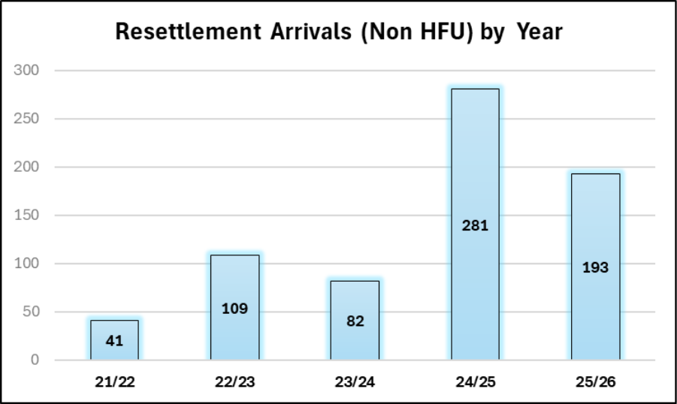Graph 01. This graph shows the number of individuals who arrived in Islington between 2021 and 2025 across the Afghan and Global resettlement programmes. See graph 02 for a breakdown of arrivals per each scheme. Please note this graph does not include these numbers for Homes for Ukraine (HFU).
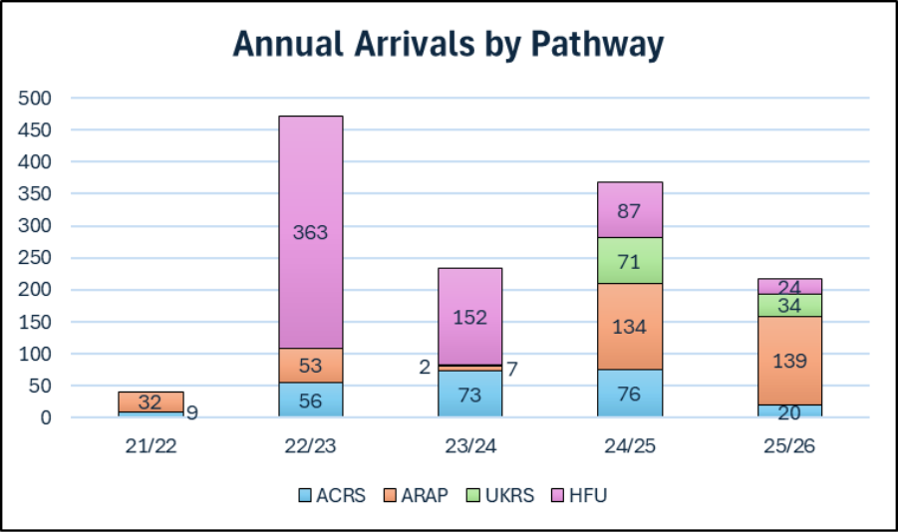Graph 02. This graph shows the number of individuals who arrived each year across the years 2021- 2025. This graph shows the number of individuals for each scheme, including Homes for Ukraine and the UK Resettlement Scheme (UKRS).
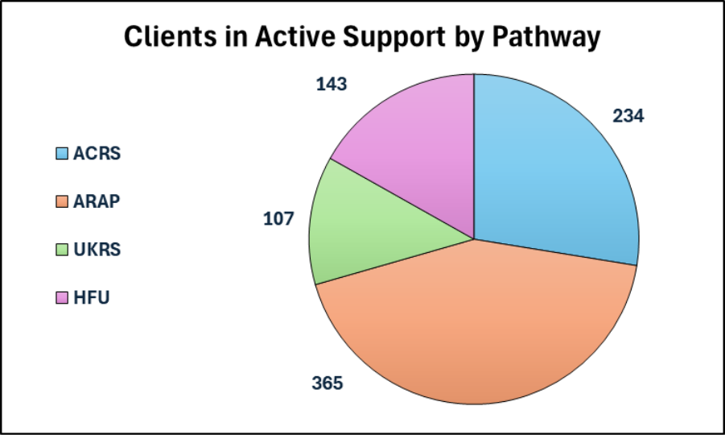Graph 03. This graph shows the number of individuals in active support according to pathway of resettlement.

2.2.2. Timeline of Islington resettlement programmes
- 2015: Resettlement of unaccompanied asylum-seeking children (UASC) who fled the Syrian Civil War.
- 2016: Islington is one of the first boroughs to join the Vulnerable Persons/Children Resettlement Schemes.
- Dec 2015 - Aug 2019: 18 different households were resettled, consisting of 33 adults and 31 children.​
  - Initial support (one month) was provided by Refugee Action. A team in the council consequently took over.
  - Oct 2017:​ Refugee Action is commissioned to provide resettlement support during first year following arrival. ​​A local charity, Manor Gardens Welfare Trust, provided specific support to the families in the later years of their resettlement. Refugees who arrived via the Syrian scheme were granted leave to remain. All Syrian households were supported with legal representation and fees to apply for British citizenship after 5 years in the UK.​
  - Islington provided a mix of integration support and accommodation. Housing was provided through Private Rented Sector (PRS), Islington Lettings and Housing Association (HA). However, lack of available housing and a housing key contact were identified as the main barriers in extending the programme.
- 2021: Islington starts welcoming Afghans (through different pathways) following the evacuation from Afghanistan.
  - A bridging hotel opened in Islington in September 2021 accommodating some of the first evacuated Afghan families. Islington resettled 12 of these families in properties in the borough.
  - Islington commits to resettle 35 families (15 household in the private sector and 20 buy-back properties).
  - All resettlement services are brought under and delivered in-house by the council.
  - Each household is assigned a specialist council caseworker who supports them in settling into their new neighbourhood. The charity Kurdish and Middle Eastern Women’s Organisation (KMEWO) delivered support and wellbeing activities for families.
  - Housing: funding from the Greater London Authority (GLA) and the Department for Levelling Up, Housing and Communities (DLUHC) to buy back over 400 ex-council homes. This funding was expanded further in 2023 (see below). Buy-backs are not only assigned to people who fled Afghanistan, but also Ukraine, as well as families and individuals on temporary accommodation waiting lists.
- 2022: Islington Council provides support for local residents who host Ukrainians in their homes.
- 2023: Islington is awarded Borough of Sanctuary status.
  - The Ministry of Housing, Communities and Local Government (MHCLG) launches the Local Authority Housing Fund (LAHF) programme, to recognise the additional homelessness pressure that local authorities would face with Afghan and Ukrainian families arriving in the country. The programme includes a component for general needs temporary accommodation to alleviate homelessness across all resident cohorts.
- 2024: Islington begins resettling families referred through the UK Resettlement Scheme (UKRS), i.e. ‘global resettlement’, created in 2020 and open to anyone in need of protection and third-country resettlement as identified by UNHCR.
- 2025: Islington begins successfully ending support for Afghan families at the end of their funded resettlement period.

3. Methods and ethics

The research is a multi-method study including desk research (document reviews, analysis of data), semi-structured interviews and focus groups with key stakeholders. Moreover, interviews with Syrian participants and longitudinal methods using follow-up interviews with resettled Afghans were conducted, the latter over three waves from 2023-2025, to create a unique rich source of lived experience narratives.
This project received ethical approval from London Metropolitan University’s Research Ethics Committee. All participants were given an information sheet about the study, translated into relevant languages as required, which included details about how their data would be treated and instructions on how to withdraw from the study (should they wish to do so). This information was repeated at the beginning of each interview and focus group.
Particular attention was dedicated in explaining to participants that although commissioned by Islington Council, the study and the research team were independent. Names have been removed, and all participants have been given ID codes to protect their identities (e.g. Stakeholder 01/ ‘S1’; Syrian 01; Afghan 01).
Translation was provided where required. Interpreting assistance was provided by Lina Mani and Gul Ghutai Waizi at Manor Gardens and KMEWO respectively. To ensure regular and consistent interpreting for the interviews with Afghan participants, as and when needed, we hired additional team members, Farzana Adell and Mohammad Ibrahim Muzamil, who are both Afghans and were students at London Metropolitan University.
All interviews and focus groups were audio recorded and fully transcribed. Data thus collected were stored following GDPR rules and held securely in password protected folders in London Metropolitan University’s One Drive system. Interviews conducted in person were transcribed by a professional transcription company, Transcribe It, which has an agreement with London Metropolitan University and an established track record of transcribing highly sensitive data. Interviews conducted online were recorded and transcribed by the research assistant, Alessia Dalceggio.
All participants were given a £20 ‘thank you’ voucher for their participation in the study.

3.1. Desk research
The commissioning team at Islington Council provided the research team with documentation intended for scoping review and analysis. A total of 19 documents of various nature were shared, including (but not limited to) government policies and guidance on resettlement, funding instructions, internal policies and briefings, and PowerPoint presentations. The research team reviewed, summarised and analysed this grey literature in conjunction with academic literature on resettlement and integration.

3.2. Interviews and qualitative data analysis
This research is a qualitative study and includes structured interviews with stakeholders from Islington Council and partner organisations, as well as Syrian and Afghan people resettled in the borough. The study also included three focus groups, one with Afghan women organised and hosted by KMEWO and two with caseworkers from the NRPF Refugee and Migrant Service team (in 2023 and again in 2025).

3.3. Stakeholder interviews
Research was conducted with a total of 25 stakeholders, some of whom were interviewed more than once in different research encounters (interviews and focus groups).
In the initial phase of the project (2023-2024) we interviewed 10 stakeholders, namely:
- 8 members of the NRPF Refugee and Migrant Service team in Islington Council, including senior management and frontline workers, interviewed individually or in a group format.
- 2 stakeholders from local NGOs working in partnership with Islington Council, interviewed individually.
In the second phase of the project (2025 extension) we conducted an additional wave of interviews with 17 stakeholders. These included:
- 5 council staff, working within or in partnership with the NRPF Refugee and Migrant Service team, including specialists on ESOL (x1), employment (x2), benefits (x1) and Borough of Sanctuary (x1).
- 2 members of external partner organisations, including providers of mental health services and legal advice.
- 7 members of the NRPF Refugee and Migrant Service team focused on Afghan resettlement, interviewed in a focus group format and one individual interview.
- 3 staff members from local schools, primary (x1) and secondary (x2). These interviews were supplemented by a site visit.
These research encounters, particularly those undertaken with the 17 stakeholders in 2025, have provided valuable insights into the provision of services and partnerships that underpin the resettlement programme across the borough. All interviews and the two focus groups were recorded and transcribed. Transcripts were then systematically checked for accuracy and analysed thematically to inform the findings of this evaluation.

3.4. Syrian and Afghan residents' interviews
In the first phase of the evaluation (2023) we conducted interviews with a total of 40 resettled participants, namely:
- 11 Syrian residents
- 29 Afghan residents (25 individual interviews plus 4 additional participants from a women’s focus group)
Given the longitudinal approach of this evaluation, 21 Afghans residents were re-interviewed in 2024 to track their progress over time. In 2025, when the project was extended, we followed up and interviewed 20 of those participants again. Thus, across the duration of the project over 80 interviews have been completed with resettled persons. Because of the longitudinal design of the research, we only followed up those Afghans who were already resettled in Islington by 2023, no new arrivals were added to our project.
By the end of the project, Afghan participants were interviewed during each year of their resettlement experience in 2023, 2024 and 2025. These 3 waves of interviews have generated a unique source of rich longitudinal data of lived experiences of resettlement and provide significant, valuable insights into how experiences change and develop over time.
Many of the Afghan residents are coming to the end of their formal support under the Resettlement Scheme and hence these latest interviews provided an opportunity to assess how they plan to navigate their lives in Islington beyond the resettlement scheme.

3.5. Participants sample description
Given the purpose of the research, with the invaluable assistance of stakeholders, including Manor Gardens and KMEWO, we recruited the targeted sample of 40 individuals resettled in the borough of Islington under specific schemes, i.e. ARAP and ACRS for Afghan participants, and VPRS for Syrian participants. Since access to the participant cohort had been facilitated by council stakeholders, as previously mentioned, particular attention was given to explaining to participants that although commissioned by Islington Council, the research team was independent and bound by confidentiality.
In terms of demographics, the Afghan cohort:
- Included 15 participants who identified as female and 14 who identified as male.
- Varied greatly in age, with participants between the ages of 19/20 and late 60s.
Among the Syrian participants:
- 7 individuals identified as female and 4 as male.
- Age varied from early 20s to mid-50s.

4. Findings

4.1. Islington Resettlement provision
The first section of the findings presents a summary and analysis of Islington’s model and resettlement provision, based on the desk research as well as stakeholder interviews and focus groups.

4.1.1. NRPF, Refugee and Migrant Service
Afghan resettlement in Islington is delivered in-house by the Resettlement Team, which sits within the NRPF, Refugee and Migrant Service (Homes and Neighbourhoods Directorate). As of 2025, the NRPF, Refugee and Migrant Service include:
- Afghan and Global Resettlement Schemes
- Homes for Ukraine
- Asylum Services
- No Recourse to Public Funds (NRPF) Casework
- Borough of Sanctuary
- NRPF Network
- Advocacy and Campaigning
- Research, Development, Funding &VCS Partners
- Coordinating Annual Events
An overview of each service is provided in Appendix 02.
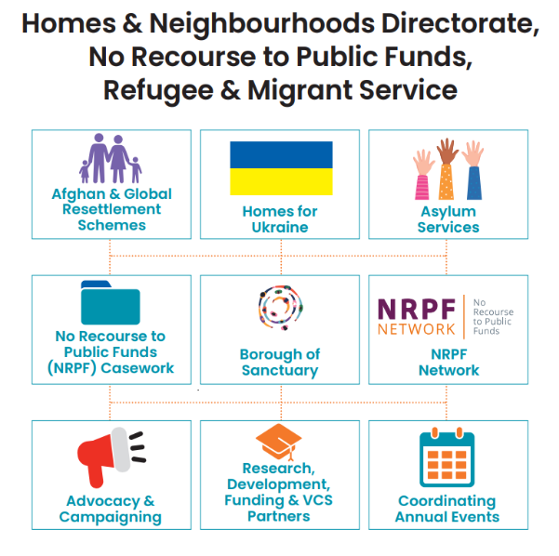
Image 01. This picture shows a visual representation of the NRPF Refugee and Migrant Service at Islington Council as of November 2025.

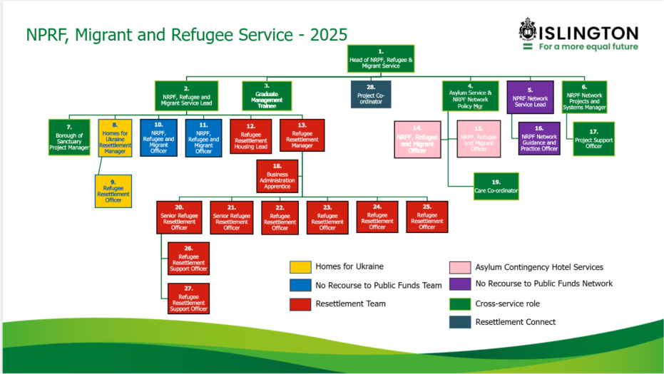Image 02. This picture shows an organigram of the NRPF Migrant and Refugee Service team and has been shared as part of the document review.

4.1.2. Islington Resettlement Team and partners
The Resettlement Team is currently composed of 12 members, 5 Refugee Resettlement Officers, 2 Senior Refugee Resettlement Officers, 2 Refugee Resettlement Support Officers, 1 Refugee Resettlement Manager, 1 Refugee Resettlement Housing Lead, 1 Business Administration Apprentice.
In undertaking our evaluation, we noted how the Resettlement Team expands to include strategic partners in other local authority services, funding 3 specialised roles in iMax (Income Maximisation), 3 in iWork and 2 in Adult Community Learning (ACL). Importantly, we also observed Islington’s partnership approach with external organisations to provide holistic support to resettled families and individuals through collaborative work with external partners, namely the Traumatic Stress Clinic, Brandon Centre and University College London Hospital (UCLH) RESPOND Clinic, as well as with organisations such as the Kurdish and Middle Eastern Women’s Organisation (KMEWO) and the Refugee and Migrant Forum of Essex and London (RAMFEL). A brief description of each service has been provided by Islington Council and is included in Appendix 03.
Throughout our interviews with key stakeholders, we had the opportunity to observe the integration planning and services provided by the team, particularly casework support and housing, as well as coordination with other services. These are presented and exemplified below.
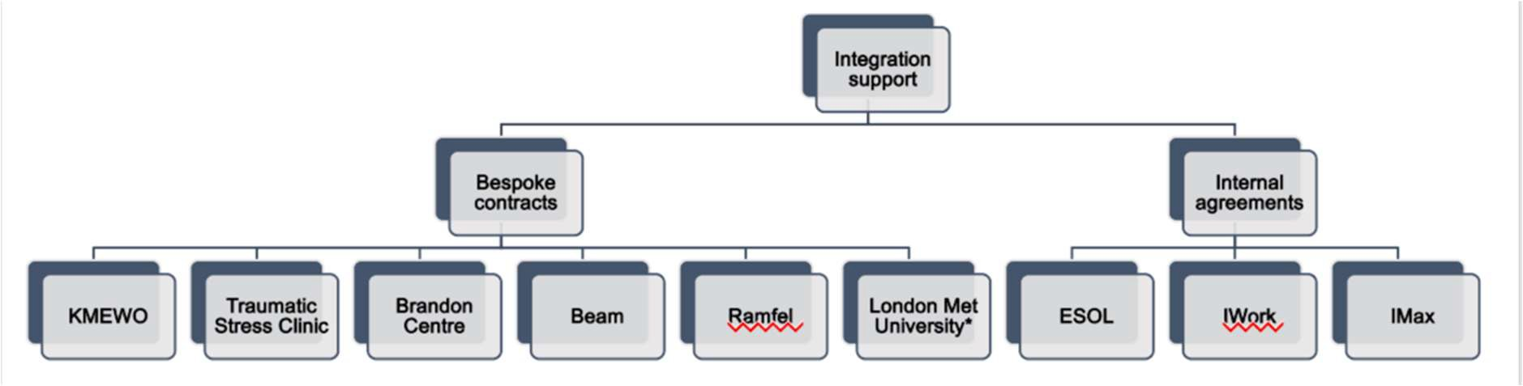
Image 03. This flowchart was provided by Islington Council as part of the document review. It shows the bespoke contracts and internal agreements with partners at the time the research was conducted.

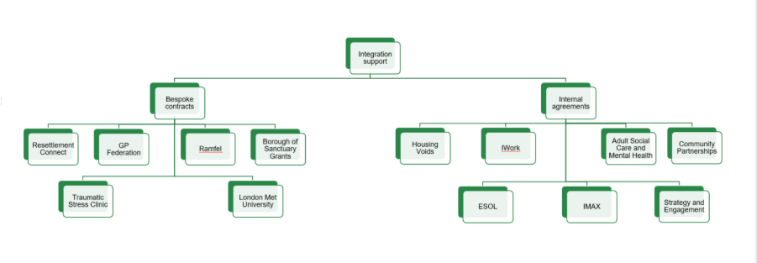Image 04. This flowchart shows the bespoke contracts and internal agreements as of November 2025.
Casework support: interviews with caseworkers highlighted the type of holistic support provided from the very beginning ‘we take over from the day of arrival’ (S2), and in some cases even before families have officially moved to the borough. We were informed that each caseworker holds a caseload of approximate 10 to15 households depending on complexity. Caseworkers provide support up to three years, with the most intensive support in the first 12 months (although this may be extended for families and individuals with complex needs).
We have noted how the intensive support provided particularly within the initial few weeks of resettlement addressed important aspects of starting life in a new borough and was focused on welcoming new residents: ‘[we’re] telling them exactly what's going on in the area. This is the bus stop, that is the train. And, when it comes to payment trying to tell them a little bit. So that is starts from there, basically building a bit of rapport, trust there’ (S7).
Caseworkers provide support regarding multiple aspects of resettlement, including housing, education, and coordination with external partners for health and wellbeing, employment and other services: ‘I’ll be arranging appointment with other organisations, like DWP or IMAX … the Tenancy team’ (S7). Caseworkers also collaborate with other organisations beyond the partners listed in Image 2 above; for instance, HealthProm and Refugee Education UK, who respectively coordinated a Saturday tuition class for Afghan children and provided education mentors.
An Integration Plan is drafted with all individuals over 16 years old, touching on 8 ‘scales’ based on the Home Office Indicators of Integration (2019). These scales are Housing, Money, Practical English, Education and Work, Family and Children, Community and Connections, Laws Systems and Services, and Health and Wellbeing. Our review indicated that caseworkers organised the plan via the ‘Outcome STAR’ tool and tracked progress against 5 stages, going from ‘1- Urgent Needs’ all the way to ‘5- Self-Reliance’ (Journey of Change, image 3). An analysis of three STAR Chart shared by Islington Council showed the bespoke and personalised approach provided to resettled residents in Islington. As this tool was being used by Islington Council Resettlement Team at the start of our evaluation, it underpinned the analysis of our qualitative data.
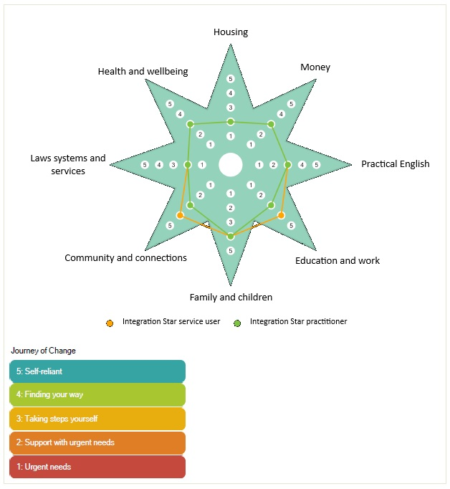
Image 05. This is an example of an anonymised ‘Integration STAR’ in use. The orange line indicates the STAR as completed by the ‘service user’, i.e. the resettled person, and the green line is by the practitioner.
In June 2025 we were made aware that the Outcome STAR tool was no longer in use and the team is now using a bespoke case management system called Resettlement Connect, which was developed internally: “we wanted a system to track integration and to lead our work that really is embedded into our day-to-day work” (S21). As explained by S21, this system was created alongside the caseworker team and “distilled down [the] main markers of integration [...] to understand what core integration looks like” (S21). This new system provides caseworkers with a birds-eye-view of the support systems and partnerships already in place and helps identify areas for development and improvement. In this system individuals are assigned a “red, amber, green rating” (S21) for each of the integration categories, and their household is also assigned an overall colour-based rating. The integration categories are:

- Access to Education
- Employment & Volunteering
- Health & Wellbeing
- Financial Stability
- Housing
- Immigration
- Local Living
- Safeguarding

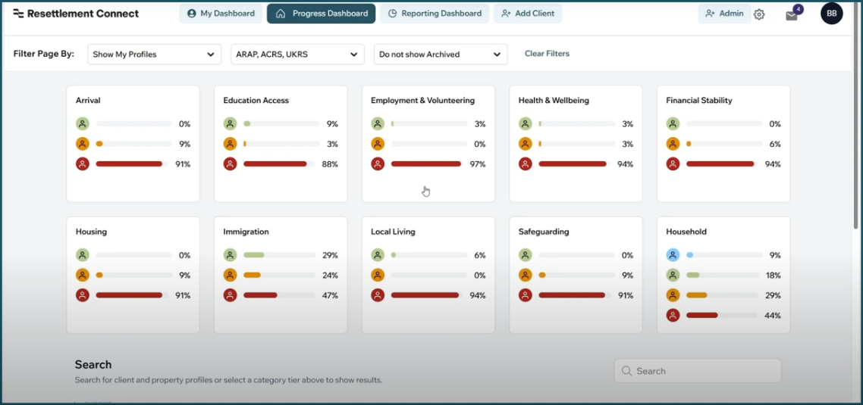 Image 06. This image is a visual example of the Progress Dashboard of Resettlement Connect.
Under the Afghan resettlement programme, the council is funded to provide support for up to three years (see Appendix 04 for a visual representation of case progression). This begins with intensive casework support via a named refugee resettlement officer (caseworker) before transitioning to drop-in only support once a family has achieved a high level of independence ('Going Green' letter, see Appendix 05). Afghans who have high levels of independence are supported to access “mainstream support” (FG, S21) as and when needed, contact the Refugee Resettlement Support Officers or attend a resettlement drop-in. These drop-ins started as ad-hoc but were later standardised to twice a week in two different Islington Access Hub locations. However, for families and individuals with very complex needs, where the caseworkers recognised that after three years “they are not going to be ready” (S7) resettlement support has continued. This is part of the individualised approach provided by the team: “we’re recognising that people become more and less independent, not always based on how long they've been here, but based on the circumstances that they came” (FG, S21).
Housing procurement/support: housing support and provision changed significantly between the resettlement of Syrian and Afghan residents. The council provided housing in the Syrian resettlement scheme: ‘a few properties were secured through [Islington Lettings], which doesn't exist now, and others which are classed as Temporary Accommodation’ (S1). Stakeholders highlighted that during Syrian resettlement housing procurement was difficult, particularly because this task was added to the workload of an existing member of staff.
With the development of the Afghan resettlement model, Islington created a role for a dedicated housing lead which sits across the NRPF Refugee and Migrant Service. Housing procurement is done through Buy-Back (discussed below), private rented sectors (PRS) and housing association (HA). Besides procurement, the Lead Procurement Officer also reviews and deals with housing standards and upgrades.
Between 2021-2023, 20 ex-council properties were purchased via the Greater London Authority’s (GLA) Right-to-Buy-Back programme; a further 20 properties were also sourced (10 PRS and 10 HA). Since then, the council’s resettlement programme expanded further through the Ministry of Housing, Communities and Local Government’s (MHCLG)’s Local Authority Housing Fund (LAHF), with a commitment to purchase 310 ex-council properties for resettled Afghan and Ukrainian people (see LAHF section below). In 2024, the council began renewing partnerships with private landlords and housing associations and created move-on options for families in the 20 GLA properties. The expansion through the LAHF properties has allowed assignment of housing based on needs: “Some people have moved because maybe their mobility has gotten worse or maybe they always had mobility difficulties. And so finally we were able to offer something more suitable” (S21). Moreover, we were informed that almost all Afghans in PRS were also moved were also moved, principally into buy-backs as and when private landlords wanted their properties back. We noted that the type of housing (buy-backs vs private vs housing association) carries different tenancy agreements, although all housing is renovated to the same standards. Afghans are also eligible to join the social housing waiting lists, in the same way as other Islington residents once they meet Islington housing lettings policy residency requirements.
Local Authority Housing Fund (LAHF): the vast majority of families arriving to Islington have been housed in buy-back properties acquired via MHCLG’s Local Authority Housing Fund (LAHF) programme. Launched in 2023, this programme recognised the additional homelessness pressure that local authorities would face with Afghan and Ukrainian families arriving in the country. In addition to this, the programme includes a component for general needs temporary accommodation to alleviate homelessness across all resident cohorts. Early in the programme, Islington worked to submit a substantial bid to ensure an adequate supply of housing for local residents as well as newly arrived Afghans and Ukrainians. This work has allowed Islington to be recognised as a leading local authority for buying back ex-council properties, keep temporary accommodation costs low and prevent homelessness for Afghans and Ukrainians in the borough.
Afghan Development Grant: Islington Council’s NRPF, Migrant and Refugee Service has also developed further support for Afghans resettled in the borough. For example, the service established the Afghan Development Grant, a grant to assist Afghan refugees over 14 years old. This grant is in recognition of financial limits, worsened by the cost-of-living crisis. We understand that individuals can apply for up to a maximum of £500 at any point during their resettlement support period (36 months), and funds can be used towards a variety of educational and vocational opportunities to help fulfil personal aspirations. The grant can be used, for example, to achieve reaccreditation courses, private tuitions, gaining a driving licence, cover travel costs associated with educational/employment opportunity, family and other social/leisure activities that promote wellbeing.
Further support – Schools: due to the nature of casework, the Resettlement Team works closely with primary and secondary schools in Islington, where resettled children are present. For example, case workers help children to enrol in schools. Schools receive £4,500 per resettled pupil during their first school year from Central Government Initially, it was unclear how schools were using these funds to support Afghan children specifically. Caseworkers flagged this as an issue of their limited capacity: “we didn't really have that foresight to do the kind of work” (FG S22). However, at the time of the interview with the Resettlement Team (April 2025), they had developed a “structured way” (FG S3) to plan and discuss spending with the school. Resettlement officers arrange a meeting with the school to agree and create a Personalised Educational Plan for the student that granted these funds to the school. Funds can be used at school discretion according to the needs of the student and what is already available within the school. For example, it can be used to purchase a laptop, books, stationary, dictionaries, as well as providing access to a breakfast club or after school club. As this funding was a one-off year payment, the question remained regarding whether and how longitudinal support (e.g. access to clubs) was maintained. Caseworkers highlighted that continuation was dependent on the resources of the school. Overall insights from two schools in Islington, one primary and one secondary, are provided in section 4.1.3.
Further support – special education needs (SEN): when newly resettled refugee children arrive in Islington with special education (SEN) needs, they often have had no previous adequate education setting which met their needs. In the UK, this is achieved via an agreed Education Health and Care Plan (EHCP). Recognising that it can take a year of classroom observation to complete an EHCP, the Resettlement Team works collaboratively with Islington’s SEN team to fund extraordinary placements while the assessment is being completed. This allows newly arrived children to be in appropriate education settings during their assessments and begin making progress ahead of an EHCP being agreed. The Resettlement Team then claims this funding from the Home Office so that there is no additional cost or pressure on the local authority.

4.1.3. Overview of internal and external partners and their services
As part of the evaluation, we interviewed a total of 7 stakeholder representatives from partner services, including iMax, iWork, Adult Community Learning (ACL), the Traumatic Stress Clinic, KMEWO and the Refugee and Migrant Forum of Essex and London (RAMFEL). Below is an overview of each service as discussed during these interviews.
ACL: ACL has been commissioned by the Resettlement Team to offer 9 hours per week of ESOL provision, although their service also addresses learning in general (e.g. digital skills learning, educational trips): “it's quite wide in terms of education, mainly ESOL, but not only”. Newly resettled Afghans in Islington are referred by their case workers for an ESOL assessment. ACL has developed bespoke classes for this cohort. At the time of the interview (February 2025) there were 52 resettled people (Afghans, Syrians, Somali and Sudanese) enrolled in this service. Learners were divided into small classes, around 14 people, across various sites. Classes are offered in blocks of 3 hours, with a short break in the middle, 3 days a week. This arrangement is to facilitate those who are unfamiliar with classroom learning, as it can be exhausting to sit in that environment for long periods. The ACL team undertakes regular initial assessments, which are provided in relevant languages (for Afghans these are Dari, Pashto or English) depending on the needs of learners. These assessments consider language, as well as literacy. Those with no prior knowledge of English are assigned to the New to ESOL classes (which used to be called Pre-Entry and have no exams) and then progress through to Entry Level 1, 2 and 3. After completing Entry 3, learners can then progress to college to study English and other subjects, such as undertaking Functional Skills. Of course, not all Afghans need to start ESOL from scratch. Some already speak good English and progress directly to higher ESOL level or in some cases apply directly to college. However, there is only an intake to City and Islington College twice per year so applicants may be required to wait for a place to become available.
IMax: IMax is a service within Islington Council which sits within the Directorate of Community Wealth Building. The service is open to all Islington residents and those supported by Islington, and deals with any issue related to welfare entitlement and financial stability. The Resettlement Team employs three dedicated iMax officers to work alongside caseworkers. s. Our key informant interviewee explained their role: “we support those families and individuals directly alongside the case worker in the [Resettlement] team and it's [about] making benefit claims, disability benefit claims, housing costs, etc”. A dedicated email for connects people directly with these three workers; initial appointments are usually made in person, and further appointments are organised as needed. For resettled clients, including Afghans, IMax actively follow up with families and individuals over time through their dedicated officers, as any changes to a household could impact benefit entitlement. Where Afghans may be affected by the benefit cap, Imax can support with discretionary payments. IMax does not work directly to help people off benefits but works closely with iWork to help people who want to move on into employment.
iWork: iWork is a service within the Directorate of Community Wealth Building in Islington. Their primary role is to support local residents into employment. The team are funded for two years to take up referrals from the Resettlement Team, as well as other avenues like GPs, to support resettled refugees and migrants by providing tailored employment or training support. At the time of the interview (March 2025) there were 37 Afghans actively supported by iWork. A triage system operates to assess whether people are “job ready” or if further training and support are required. A tailored plan is then drafted, which includes (where appropriate) skills building, considering people’s interests and aspirations. This is particularly useful for people who have not been in employment before. Where people are ready and have the skills and qualifications necessary to work, the team help them identify “key skills they need to pursue specific roles”. The team takes a holistic approach looking at various aspects of employment, including CV writing, interview preparation and connections with potential employers; moreover, they work in collaboration with local partners, including Volunteer Action Islington, to support and encourage people to volunteer especially where time is needed to improve English proficiency or build specific skills. Typically, Afghans receive 12 months continued support from after entering employment, which includes mentoring, coaching and face meetings. iWork has now moved to an initial assessment model whereby all eligible adults are assessed within six months of arrival to the borough.
Traumatic Stress Clinic: in March 2023, Islington Council commissioned the Traumatic Stress Clinic, an NHS provider, to specifically support the mental health and well-being of resettled Afghans. Since then, the service has expanded to include Ukrainians and people on the UKRS schemes, however here we focus on Afghans.
As part of the service, a well-being assessment is offered to all newly arrived Afghans in the borough. Case workers liaise closely with the Clinic to ‘flag’ any individuals who might need particular support, who are given priority. Following the assessment, depending on their needs, people may be offered therapeutic support either within the Clinic itself (e.g. in case of Post Traumatic Stress Disorder) or referred to other appropriate services. Afghans experiences of well-being may vary, from low mood to severe cases of psychosis, hence treatment is dependent on needs and could include talking therapies or referrals to NHS hospitals for intensive care, as required.
Our key informant highlighted that in some cases, people do not take up the offer of support initially. This can be due to stigma around mental health, however more often it is related to “people's internal models of change, what they need and how they conceptualise their difficulties”. In other words, rather than therapy, people may engage in work, education or other activities as a way to cope. Nonetheless, some people do return later on if they decide that some support would be beneficial to them.
The service is aimed at adults, although where children are in need of support, a referral is made to work with their GP and with CAMHS (Child and Adolescent Mental Health Services). The Clinic is also working with local groups, such as KMEWO, to run women’s groups and provide support through regular sessions with a focus on practical well-being.
Kurdish and Middle Eastern Women’s Organisation: While KMEWO was initially involved in supporting Afghans placed in the bridging hotel in 2021-2022, in a quasi-casework capacity, as people started to be moved out of the hotel and resettled in Islington accommodation, the role of the organisation changed. KMEWO focus on providing group activities for families but primarily for women and girls, such as a weekly women’s group. During these sessions, they provide support in different areas, from using basic technology and digital skills (mobile phones, WhatsApp, email etc.) to wellbeing sessions on stress and sleep, to information session on domestic violence and harassment. The stakeholder explained that: “One of our colleagues is a specialist clinical psychologist”. These sessions are also an opportunity for women to socialise, meet and discuss issues with other women, and learn how to move across London on public transport. KMEWO also organises day trips and celebrations/events, e.g. International Women’s Day.
RAMFEL: the legal department at RAMFEL deals with case referrals from external partners, including NRPF, Refugee and Migrant Service, which funds immigration representation regarding family reunion, citizenship and immigration applications. The majority of these cases were reported by our key informant to be for Afghan clients. People are referred to RAMFEL directly from the council, and after an initial meeting (usually in person) the team will continue working with clients for as long as their case has merit. Support for Afghans can be supplemented by applying for legal aid: “The main benefit of that is […] expert evidence can be funded by the legal aid agency, which otherwise the individuals wouldn’t be able to pay for and that would be funding in addition to the cost of our time to prepare the application”. RAMFEL also provided a drop-in clinic during the summer in 2024, when the window for the ACRS Separated Families pathway was announced; they also provide signposting and referrals to clients’ needs when these are beyond RAMFEL’s scope.
Schools: Schools can play a key role in providing support to newly arrived children and young people, particularly those who have experienced trauma and had been out of education for protracted periods. The secondary school we visited organise a welcome week and provide information in Persian and Dari. New arrivals are paired with other students from a similar background, as a form of buddying, to help them settle into the classroom and familiarise themselves with the school’s routine. The English as Additional Language (EAL) coordinator meets with new students and their personal tutor every morning for 30 minutes. However, like the rest of the UK’s educational sector, schools face persistent structural challenges related with funding provision which were especially acute for the primary school we connected with. The funding they receive for resettled children is provided as a one-off payment, which can create uncertainty. School stakeholders reflected: “It’s been really generous [and] really good for one year, but I think it should be something that happens over time as well”. As mentioned by some school staff, communication with parents can sometimes be a challenge for schools, particularly when parents do not speak English: “Their children have to learn English to get by. But the parents are struggling. I think more work needs to be done there”. While school staff highlight the support provided by dedicated case workers in finding interpreters and communicating with parents, they would like the council to provide the school with a register of recommended tutors in different languages: “So there'd be a place where you could find a tutor for a family, because families don't know where to go, and neither do I”. Secondary schools find that helping students with no prior schooling is a major challenge: “Sometimes they get into trouble and it’s because they don't get the expectations of school”. In the secondary school we visited, pupils with limited English language or those in need of additional support join the classroom, but do not participate in mainstream lessons for a period of time whilst they catch up. During our visit to a large secondary school in the borough, we saw a girl sitting at a separate table with a classmate, working on a Chromebook using language support tools such as Lexia and Linguascope. Teachers especially appreciated the support of caseworkers in situations where safeguarding concerns emerge. For instance, stakeholders reported how quickly and efficiently the council reacted to a case of domestic violence: “there's lots of people working with this community resettlement scheme, but I see when [the pupil] is at school it’s such a positive environment, and almost like a sanctuary as well”.

4.1.4. Overall stakeholder feedback and considerations
Based on all the interviews and focus groups with the 25 stakeholders, we observed that all services provided beneficial, holistic support to resettled families and individuals. Particularly commendable is the role of the Resettlement Team and their coordination of, support to, and communication with, all partners.
Nonetheless, stakeholders emphasised that in their process of resettlement Afghans are dealing with “a variety of issues and barriers” (S11), as they navigate a new and unfamiliar environment in the UK and complex structural systems. These can result in “lots of stress” and “confusion” (S11) all while dealing with a profound sense of “loss” (S12). Moreover, from this research it is evident that Afghan participants are very diverse, and their needs and circumstances vary considerably. This was also noted by stakeholders, who discussed differential uptake of their services and/or the need to adjust the starting point of support provision on the basis of gender, educational level, professional experience, literacy, age and English proficiency. Hence stakeholders did not operate under a ‘one-size fits all’ type of provision but instead tailored their services to meet specific needs.
- What is working well
- Direct line between service providers and Resettlement Team
Partner organisations were very complimentary about the Islington Resettlement Team and highlighted their positive working relationship: “I have a really nice, close relationship with the caseworkers” (S11). Close cooperation facilitated communication and information/knowledge sharing, as well as enabling services to raise any concerns, including safeguarding, as mentioned in the above section on ‘Schools’. Informants also highlighted how the Resettlement Team was very helpful in facilitating connections with other services and key stakeholders, such as interpreters and the Home Office.
- Ring-fenced/dedicated funding
Organisations and schools reported that specific funding for the development of services for resettled people helped them prioritise and/or dedicate time, personnel and resources to address the needs and issues encountered by Afghans: “we're actually having to account for it and I think that's much better. So I think that's a real improvement” (S18).
- Dedicated, service-specific personnel
Having specific roles for the support of resettled Afghans allowed organisations to build capacity and better “identify individual barriers” to then create “a tailorized plan” (S15) for individuals or families. Specialised workers also made it easier to support Afghans if their situation suddenly changed: “if there are further issues, it goes back to that officer. So there's some sort of continuity” (S13). Moreover, having dedicated personnel also allowed stakeholders themselves to gain and develop specific skills or knowledge.
- Bespoke approach to individual, intersectional needs
As abovementioned, we noted that services had developed “individualised” (S11) approaches in working with Afghan individuals and families. The ‘bespoke’ aspect of provision was developed in recognition of Afghans’ intersecting, complex circumstances, and upon noting differential uptakes of services. For example, low English language proficiency levels could impact on access and engagement in various environments, such as schools (for parents) and in employment, sometimes regardless of their qualifications: “it’s really holding people back” (S15). Yet English language acquisition could, in turn, be affected by low or no level of literacy in Afghans’ first language. Hence, services emphasised how they operate on a bespoke system, to meet Afghans where they are, often from the assessment stage; consequently, stakeholders may plan and deliver their services in different ways according to needs. For example, ACL provided both literacy and English level assessments “to accommodate better the needs and barriers that Afghan learners face” (S11); wellbeing services noted that men preferred “one to one” conversations and women “a group format” (S12).
As discussed in section 4.1.2. (Casework) and as we will see in 4.2.8. (End of Scheme), this individualised approach also follows through to the end of the resettlement scheme, as specific needs are assessed and the required support mechanisms are identified.
Services that worked with resettled Syrians also noted that they “moved on” (S13) and became independent at a slower rate than Afghan participants. This could be due to a range of factors such as, for example, Afghans, generally speaking, having higher levels of English, and also Syrians having experienced protracted situations of displacement, for example in camps. Plus the more structured approach to resettlement now in place in the borough'. Nonetheless, we noted that Syrian women tended to fare better than their male counterparts: “a lot of the [Syrian] women had found jobs via the schools […] And yet the men, possibly because some of them were a good bit older too […] felt unsupported and didn't feel very integrated” (S13).
- Persistent structural challenges
Our analysis suggests that some of the most challenging aspects of resettlement were related to wider socio-economic and political structural systems, beyond the remit of Islington Council. For example, financial hardship due to the rising cost of living and benefit cuts, the housing crisis, protracted and complex immigration procedures, affected Afghans in their resettlement journey and consequently limited, prevented or unnecessarily complicated the provision of support by services. Stakeholders recognised that wider structural, intertwining “drivers of distress”, were very difficult to address at their core, thus support focused on what could help Afghans “cope” (S12). The intersection of these complex, lengthy systems and challenging personal and financial circumstances need to be considered also in the expectations of how much time it would take for Afghans to reach full independence. For instance, the journey to full language fluency could take much longer than the expected, ‘average’ five years: “[a] study [suggests] that it takes around 15 years for an ESOL learner, starting from scratch, to become like fully fledged employable” (S11).
- Cost of living and benefit cap
The rising cost of living was identified as a key challenge: “they didn't expect the amount of bills that they receive and the bills to be so high” (S13). Furthermore, limitations such as the ‘benefit cap’ and the ‘two-child policy’ combined with prohibitive housing costs (“rent is such a critical expense”, S16) and generally a high cost of living, constituted a challenge for Afghans to “move on” and be fully financially independent.
- Immigration changes
A complex immigration system, constantly changing rules and policies, complicates the provision of support and further affected Afghans’ wellbeing. Furthermore, stakeholders were wary of Afghan clients potentially losing trust in their support due to these frequent changes to the system, the establishment of ad-hoc, time-limited procedures and routine refusals from the Home Office: “they seem to be suggesting that there is an appropriate route, but there isn't. […] if there was a more flexible approach, […] that would avoid a lot of costly and protracted litigation” (S17).
- Future funding of the scheme
Funding cuts and/or lack of funding to address specific issues arising within services concerned many of our stakeholder interviewees. Funding cuts beyond resettlement was also a challenge, especially when stakeholders collaborated with other specialist organisations: “The legal aid sector has been sort of decimated over the past 10 years […] So it's incredibly difficult to find a legal aid solicitor and these cases are particularly complex” (S17). Moreover, as the ARAP and ACRS schemes have now been superseded by the Afghan Resettlement Programme (ARP), changing funding instructions may impact on the way resettlement can be managed locally.
---
In this first section of the findings, we have explored and analysed the services provided by Islington Council in the context of resettlement, as well as by external partner organisations. Recommendations, drafted in partnership with stakeholders, are provided at the end of this report (see section 5. Recommendations).

4.2. Qualitative Analysis (Afghans and Syrians)
To understand the lived experiences of resettled Afghans and Syrians in the borough, we now present the rich qualitative findings generated through in-depth interviews over the course of three years. The findings below are organised in eight sections, namely Housing, Cost of living, Employment, Language, Health, Education, Social Networks and End of Scheme support, in line with the Outcome Star Tool (see 4.1.2.) which was being used by Islington Council at the time the research was conducted.

Housing
Immense gratitude: All our participants expressed gratitude to the council for housing them in Islington. Participants were very positive about living in the borough because of its amenities and ethnic diversity.
Leaving hotels and initial rehousing process: When we began our research in 2023, people expressed relief at having left Home Office administered hotel accommodation. However, while acknowledging the council’s help and support, some people found the rehousing process stressful. A young Afghan woman (Afghan 01) said that she and her sisters would have liked more information about tenancy agreements and local rental costs beforehand. At that point in time, there was growing pressure from the Home Office to vacate hotels resulting in increased urgency for local authorities to find accommodation quickly. This was especially challenging in the case of larger families.
Mismatched expectations: Many participants told us they were initially disappointed with the size of their new homes in London. A man said: ‘London is a famous city and modern city and was expecting a house in London or anywhere in the UK should be very nice and big house’ (Afghan 13). Most Afghans were initially unaware of the severe housing shortage in the capital. As time went on, Afghans adjusted to the reality of London housing and were happy to see improvement in their accommodation where possible.
Moving to bigger properties: Housing large families was a significant challenge for the council; however, thanks to the LAHF funding expansion, more diverse types of properties became available to rehouse families in need of bigger accommodation. In 2024, we interviewed a father of six (Afghan 05) whose three-bedroom flat was too small. When we interviewed him again in 2025, he had been moved to a larger house: ‘So now we are living in five room house. It's in a good location. My children are happy’.
Indeed, during the 2025 interviews we noted that several large families had been/were being moved to bigger properties: ‘I changed my house. I'm relaxed. This house is so good’. A father of seven (Afghan 07) was initially allocated a three-bedroom property. By the time of our follow up interview in 2025, the council had moved the family to a four-bedroom flat. Afghan 07 was aware of the constraint the council is under regarding to rehousing, especially for families with specific needs (e.g. accessible accommodation) so he accepted the offer of a new house as it became available: ‘we are happy’.
Creative solutions: It is noteworthy that the council has also implemented several creative solutions to accommodate large families. One of these is partitioning a room to create an additional bedroom. For example, in the case of Afghan 10, a father of five, a downstairs room had been partitioned into two separate rooms.
Another council strategy was to split large families into two separate homes. That was the case for a family of eight, who were placed in two different apartments 15 minutes’ walk apart. In 2025, the family was still separated and was hoping an opportunity would become available to move to a larger house where they could all live together.
Housing costs and tenure: While for many Afghan families moving to a larger property was a priority, this raised the inevitable question of higher rents. As discussed in the following section 4.2.2. Cost of Living, families were having to make adjustments to their lifestyles and expectations in order to afford living in central London.
Some participants had also expressed concern about tenancy agreements with private landlords.
- In 2024, a father of three (Afghan 12) told us that he was worried because their landlord wanted to terminate the tenancy and sell the property. When we interviewed him again in 2025, we found that the council, under homelessness duties, placed the family in a LAHF property, with which they were happy. The man hoped that he would be able to buy his own property one day.
- In 2024, an Afghan couple (13-26) were happy with their home: ‘it is close to the train station, close to the school, close to GP, and close to markets’. However, they were concerned that their landlord may want to sell the property when their tenancy agreement ended. By 2025, they had been placed in a council-owned LAHF property under homelessness duties after their private sector property was sold.
As explained by S21, a manager from Islington Council, some Afghans are moving from the private-rented sector into LAHF properties ‘in order to prevent homelessness when their original private-rented properties were sold’. A few Afghans have also joined the social housing waiting list, once they met the residency requirements and other eligibility criteria, along with other Islington residents, and will need to wait for suitable properties to arise.
To conclude:
- Research participants are grateful to the council for providing them with a secure home; certain challenges persist, especially for larger families, although with the introduction of a greater number of available properties (via LAHF) families’ experience of rehousing has been positively affected.
- Afghans had been unaware of challenges rooted in structural conditions related to the UK housing crisis and rental prices; hence, some initially struggled to adjust to life in London, partly due to their expectations about housing size and availability. As time went on, their perceptions and expectations aligned more with the reality of living in London and were particularly happy with the efforts of the council in providing more suitable accommodation for their needs.
- While the council has supported families to move to more suitable properties with the introduction of the LAHF programme, rehousing large families still carries logistical challenges and difficulties around housing availability.

Cost of Living
Unexpected high costs: During our first round of interviews in 2023, participants were still adjusting to life outside the hotels. Some indicated that they had not understood the true cost of living before moving into their new homes. A male interviewee explained that, whilst living in the hotel, other people had mentioned that electricity, council tax and other utility bills were expensive, but he had not fully understood the implications until he actually moved to the new home: ‘now we are experiencing everything, it is reality, expensive’ (Afghan 07).
Of course, it should be noted that many families were impacted by the ‘fuel and cost of living crisis’ started in 2021/2022, when costs soared for all UK households and, by the Government’s own admission, pushed millions of people into ‘fuel poverty’. For Afghan families, newly settling into flats and managing budgets, the very high prices of utilities proved a shock and a great worry: ‘£400 all bills. [...] everything is rising’ (Afghan 12).
Gratitude for council’s support: Many participants expressed their gratitude to the council for helping them to obtain financial assistance through Universal Credit. This has been crucial in helping them to manage their lives in London.
- A couple with several young children, Afghans 22 and 23, stated they were: ‘really thankful for that and now we got used to spending less but we think, once we get our job, we can spend better’.
- Another Afghan man said: ‘The money we get from the council, we are thankful for it, however, it is not enough for the entire cost of our family’ (Afghan 15).
As quoted here, it is apparent that many participants perceive this support as coming from ‘the council’ rather than from central government departments. This also means that any criticism is also likely to be directed at local councils rather than central government. As noted by a key stakeholder (see section 4.1.3.), the two-child benefit cap took a real toll on large families with multiple children.
The cost of living in London: Some participants expressed difficulty in managing their finances due to the high cost of living in London. A female student, (Afghan 06) who shares a flat with her siblings, highlighted the need to control expenses after realising the high cost of living in London. For example, taking the bus or walking rather than getting the tube. A male participant said that his family mostly look for cheaper markets to manage their expenses ‘We are looking for a Sunday market, Sunday market is cheaper’ (Afghan 07).
The high cost of rents in London was mentioned by several participants. For example, Afghan 18, a married man with a young family, had a full-time job, when we met him in 2024. However, he found it challenging to pay all the family bills, including their rent, from his salary: ‘One of the significant problems that we have faced so far... because the rent is £1,800 and I am the only one who is working full time’. Thus, despite earning a good salary, he stated: ‘All this money is going out for the payment of my bills and the rent of the house’.
Impact on lifestyle and well-being: Several participants said that their living standards had decreased in the UK from the status they had enjoyed in Afghanistan. For example, Afghan 12, a former Commander in the Afghan army, now works as a security guard in a London hotel. He reflected on how his family’s living standards had changed: ‘In Afghanistan we had more, yeah, the life was – because we had our own car. We didn’t use bus. We had our big garden’. A former judge and his wife, who had very high social status in Afghanistan, were struggling to adapt to their very different lifestyle in London: ‘we cannot even save that money to buy clothes. My husband needs to do his haircut- we can't save money for that’. (Afghan 16 and 17)
Income management: As discussed in the following section (4.2.3.), employment was a major concern for many participants, especially finding well paid and secure jobs. Moreover, participants who are students at language centres, colleges and universities find it difficult to balance work with their studies. For those who were full time students, the lack of benefits proved a financial challenge:
we became full time students, there is not kind of benefits available apart from the government loan and the maintenance loan for us (Afghan 04).
To conclude:
- Afghans are very grateful to be able to access financial support, although as with other residents in London, the higher cost of living in the city poses a considerable challenge. Moreover, their resettlement coincided also with the rise of living costs and the fuel crises in 2021/2022, which also impacted many other UK households.
- For large Afghan and Syrian families, with many children to support, the financial pressures are especially apparent and a great worry to parents, especially when affected by the two-child benefit cap.
- Afghans’ future financial security depends upon the opportunity to find well paid employment. However, as discussed in the section below, their experiences of navigating the labour market are quite varied.

Employment
Heterogeneous occupational trajectories: The Afghans interviewed in this evaluation had varied employment trajectories. This is not surprising as the interviewees varied enormously in terms of age (from teenagers to people in their 60s), language proficiency, skill set, education level and prior occupational experiences.
Our research found that people with good English language skills managed to get jobs more easily and more quickly than those with little or no English. For example:
- Afghan interviewee 12 had been an Army officer in Afghanistan, he had worked closely with British colleagues and spoke good English. He quickly secured a full-time job as a security officer in a large London hotel.
- Afghan 07 and Afghan 13 were both highly qualified engineers and spoke excellent English. These men had managed to re-activate their careers very quickly and were working full time in professional jobs.
- Afghan 01 completed her MA degree at a London university and then secured a job as an interpreter employed by the Ministry of Defence.
- Afghan 18 had completed an MSc in cyber security in the UK, spoke fluent English and got a professional job. Re-interviewing him over three years, we observed his trajectory; by 2025 he had embarked on a fully funded PhD programme.
Women’s varied employment trajectories: Some women had never worked in Afghanistan, so had no work experience at all. Moreover, many of the married women we interviewed were fully engaged as wives and mothers. Indeed, some of these women had no formal education whilst growing up in Afghanistan and are illiterate in their own native language. One woman told us that when she started ESOL classes in London, it was the ‘first time I took a pen in my hand’ (Afghan 27).
As another participant explained:
in Afghanistan there is still a male ‘breadwinner culture’ so the expectation is that the husband will earn enough to support the entire family (Afghan 18)
In the context of high living costs in London, it is difficult if only the husband is working and supporting the whole family, as Afghan 07 explained: ‘Only I have job. My salary is £2,600’. Therefore, enabling women to enter the labour market is important for the overall financial wellbeing of the whole household.
Moreover, it is noteworthy, that for some women, particularly those with young children, the idea that they have to look for jobs may seem quite unusual. In some cases, this could result in a perception that the Job Centre has unrealistic and unfair expectations of these women to enter into paid employment (Afghan 11).
However, some women have been managing to build their careers:
- Afghan 08 had held a senior administrative post in a large organisation in Kabul. She was highly educated and spoke fluent English. She got an initial job working part time in a local NGO. Later she secured a job working with a large employer in the borough.
- Afghan 06, a young woman in her 20s, had been a student in Afghanistan. Upon arrival in the UK, she was keen to pursue a career in accountancy or finance. Whilst studying at college, she got a summer job organised through iWork. Working in the accounts department of a large London hotel, she gained valuable work experience that also enhanced her university application.
We found that some women, despite speaking no English upon arrival in the UK, were making huge strides in reactivating their careers.
- Afghan 09 had been a teacher in Afghanistan. She spoke no English but was determined to learn and, despite having 5 young children, she devoted tremendous time and energy to learning the language. She then started to volunteer in her children’s school. Over time, her managers were so impressed by her hard work that they offered her a part-time post. During follow up interviews in 2024 and 2025, she told us that her work hours had increased, and she was working towards a teaching qualification: ‘My job is so good. Yeah, I'm happy with my job.’ (Afghan 09)
The experience of Afghan 09 is perhaps a good example for others because she had to learn English from scratch. It is clear that language support, combined with volunteering, facilitated her route into employment. Of course, the fact that she was educated and had worked in Afghanistan also enabled her progression into employment in the UK. It needs to be recognised that many of the women participants resettled in Islington have little or no prior employment experience and, as noted above, some had little previous education. Furthermore, lack of English language proficiency is also an obstacle to paid work.
Language is key: The significance of language proficiency cannot be overstated. Our research demonstrates that it may be particularly difficult for those with limited English language proficiency and little education or work experience to successfully obtain a job.
- One man who spoke little English told us he was applying for cleaning jobs in schools and offices. He had recently applied for 6 jobs but did not get a single interview (Afghan 22).
- Afghan 11 told us about a jobs fair, organised by the Job Centre, attended by employers like Lidl. He applied to several of these employers but did not get any job because of his lack of English proficiency.
- Afghan 05 worked for the army. He initially struggled to find a job because of his limited English language. When we re-interviewed him in 2024, he told us how the job situation was causing him some depression. By 2025, he had progressed to English language Entry 3 and had found a part time job working in a shop. Ultimately, he hoped to set up his own business, such as a shop or food stall, and become self-employed.
We found evidence of a gradual increase in employment over time:
- Afghan 10 had worked in the medical unit of the army as a paramedic. When we first met him in 2023, he was keen to retrain as a nurse or ambulance paramedic. But he struggled with English. By 2024, as he continued to attend ESOL classes, his confidence in spoken English was growing. When re-interviewed in 2025, we found that his English had noticeably improved, and he had found part time employment as a delivery driver.
Qualification recognition: Many of our participants were highly qualified and held skilled jobs in Afghanistan. But those qualifications and prior experiences did not necessarily translate easily into the UK context. For example, Afghan 12 wanted to undertake a master’s degree at a London university. He perceived education as a route to a better job: ‘I have to do something for my life, from how long I will be a security officer in hotel?’ However, his university application was rejected, partly because of English language fluency but also because his prior qualifications from Afghanistan were not recognised: ‘I wanted to join that university. Because I have two master’s degrees, one is in Hospitality Management and the other was in Administration and Business’.
A key finding of our research is the risk of long-term de-skilling: People who have skills, prior work experience and are keen to find a job, are struggling because of language barriers. Regular ESOL attendance is clearly resulting in improved English proficiency. Gaining local work experience in part time jobs can be a first step on the career path. However, it is important that they do not get stuck in low-paid, dead-end jobs.
The experiences of Syrians are relevant here. We found that while some Syrians, especially younger people, learned English relatively quickly, those who were middle aged appeared to be struggling, even after 7 years in London.
To conclude:
- Our findings reveal mixed employment patterns amongst resettled Afghans.
- English language and prior qualifications are key. While some got jobs and are doing well, many are struggling to find employment, despite having good skills, because of language.
- Ongoing support with language is crucial to ensure that they can get decent jobs and re-activate their skill sets.
- Many women will also need to work to contribute to the household finances, given high living costs in London. Some women are already working and doing well. Others need more support with language and basic training, especially those with limited prior education in Afghanistan.

Language Learning and Proficiency
The importance of language: Language learning and English proficiency are two key aspects of both Afghan and Syrian resettlement in the UK. As discussed in the previous section, being able to speak English is a determining factor in participants’ access to employment, making wider connections across society, and, as we will see later, in their engagement in education (see section 4.2.6. Education).
Language emerged as a key contributor to independence, both in terms of participants being able to contact services and ‘solve our problems’ (Afghan 21) and safely navigating their environment, as explained by Afghan 16: ‘I really want to learn English at least to help myself’. In the words of Afghan 15, a man in his 40s ‘once I learn the language, I can do anything’.
Participants’ proficiency in English varied greatly; even though all participants were (or had been) engaged in English language courses and/or ESOL classes, since arriving in the UK, individual characteristics such as age and previous education, existing literacy in their own language, as well as wider factors such as childcare and access to appropriate classes, impacted on people’s learning journey. A key finding from our longitudinal research is how language proficiency has changed over time. Many participants attended regular ESOL classes and had significantly improved their confidence in spoken English over the 3 years of this research. However, we also noted that some were still struggling to communicate even in basic English.
Generational differences and prior education: Younger generations, and especially primary-school children, were much quicker at learning English. When we had the opportunity to interview families in their own home, it was common to hear young children speaking fluent English, often with London accents. When discussing the ease with which children picked up the language, Afghan 13, a father of two, remarked of his 5-year-old son:
Yeah, but for kids I think it’s much easier. Sometimes he plays with the toys and talking with himself in English (Afghan 13)
We noted that those who had made great strides to learn English, sometimes from scratch, tended to be young adults who had been highly educated, prior to arrival in the UK. They were motivated to learn and were familiar with study techniques.
For example, two sisters, Afghan 04 and 06, having arrived in UK in 2021 with little English, by 2025 had both successfully gained admission to university: ‘I came like with the mindset of “I have to go to university, and I have to continue my education” (Afghan 04).
A young mother, Afghan 19, had been a university student in Afghanistan. Despite arriving in London with no English, by 2025 she had enrolled in college to study GCSE Maths and was determined to apply to university in the coming years.
Our findings indicate that older generations, and older men in particular, were among the participants who struggled the most in learning English. Often this was because they had never needed to learn or speak English in their career or everyday life; as Afghan 17, an educated, older man, and his wife, Afghan 16, remarked:
I graduated a long time ago and in that time we did not have English language. I know Arabic (Afghan 17)
My children know English but I didn’t know that I move from Afghanistan to somewhere else to learn English (Afghan 16)
Older generations tended to rely on technology (translation apps) and their caseworkers. Parents often received support from their children with interpreting and translating:
I am using Google translate to solve problems, however, the first son and daughter are also good at speaking English (Afghan 15)
ESOL classes and language provision: Many of the Afghans participants we spoke to attended ESOL classes up to 9 hours per week. For example, Afghan 09, a mother of 5 children, attended ESOL three times per week. Moreover, she also takes every opportunity to practice outside the classroom: ‘when I cook in the kitchen… I listen to YouTube channel for grammar for understand the spoken English’.
While all the participants valued the opportunity to attend free ESOL classes, it is clear that those who quickly developed English language proficiency also used other tools: ‘I didn't rely totally on the class and materials, so I mainly focused myself on searching online different tips of learning English, resources’ (Afghan 04). Hence, digital literacy is also a factor in how people access additional language resources.
Some participants requested more ESOL classes:
I joined the class three hours per day, it’s only three hours per day. The other four days are free, so once we go three days a week we have a gap of four days, so in-between four days we forget everything so we cannot develop learning and that’s a problem for us (Afghan 05)
Participants with very young children and new mothers were prevented from accessing ESOL classes at college, due to lack of childcare provision. To mitigate this issue, and to provide extra support for women, further classes with childcare were organised by Islington council and a women’s organisation. These opportunities proved popular among participants and much appreciated:
I’m also thanking Islington Council that provided for us the programme on Fridays that helps us, that we have learnt a lot the English language from the beginning until now (Afghan 28)
In the final stage of our three-year longitudinal research, as we followed-up participants in 2025, we noticed varied levels of improved language skills. Some were now speaking English confidently. Other participants showed improved comprehension skills but had not advanced enough, or did not feel sufficiently confident, to speak in English with the research team. This was due to a number of factors, including a lack of opportunity to practice English conversation outside the classroom setting. As noted by a stakeholder (see section 4.1.3), it can take many years of intensive learning to gain full fluency in English.
In the context of health and family related challenges, some people found it hard to prioritise learning English:
- Afghan 20* had not attended college for six months ‘because of my health issues, particularly my operation’ and so ‘they dropped me from the college’.
- Afghan 23* explained: ‘It has been two years. I'm not going properly. The previous year, my mother passed away, and last year my father passed away. Because of family issues and some pressure, I'm not able to go properly to college’.
(*speaking through an interpreter)
In this context, our findings from the Syrian interviews are relevant. We observed that middle-aged and older Syrians, particularly men, even after living in London for over 6 or 7 years, are still struggling to learn English.
Like several other Syrian men we met, Syrian 04, who is in his early 50s, experienced a considerable deterioration of his health following the war and years in a refugee camp. Despite attending ESOL classes 3 times per week at City and Islington college for 5 years, he told us in English: ‘I try everything, anything but my language is slowly, very slowly’. He would prefer to just have conversation classes and not worry about grammar, as the interpreter explained: ‘he doesn’t really care about the grammar, more just to speak, just to have a conversation…’ As a result of his inability to communicate in English, despite attending ESOL for years, he feels disconnected from wider society.
Interestingly, we noted that several Syrian women seemed to be learning English more quickly than their male relatives. For example, Syrian 09, a single mother in her late 40s, attended college and finished Entry 3 English. She recounted how the help of her classmates, teacher and also her adult children, was crucial for her language improvement. Syrian 11, a young married mother of 2 young children, noted that her husband, who is disabled, had dropped out of ESOL classes. By contrast, she has made good progress, is confident communicating in English, and still attending classes 3 times per week. She showed remarkable commitment to learning English, despite having small children and supporting her husband with a disability. She told us: ‘I have to leave early because my son finish at 12, so I left the college 11.30 so I can pick up my son from the nursery’.
To conclude:
- Our findings clearly show that English learning is not only a significant factor that supports people through their resettlement, education and career re-activation, it is a skill that many participants are eager to learn.
- Language proficiency among both Afghans and Syrians varies over time. Primary school children and young adults, who were highly educated before arriving in the UK, tend to pick up the language more quickly. Older generations, particularly men, find it the most challenging. We also noted generational differences in language acquisition amongst Syrians.
- Language emerged as a key contributor to independence, both in terms of participants being able to contact services, addressing their challenges and safely navigating their environment. Thus, continued ESOL provision, and even extended opportunities to enhance participants’ language learning, are immensely important.
- While volunteering and employment opportunities would greatly improve both Afghan and Syrian participants' English, they often require a high level of English proficiency from the outset, leading to a catch-22 situation.

Health and Trauma
Our research has found clear evidence of on-going health challenges, especially mental health, but it is also apparent that many Afghans are accessing support in Islington and managing their conditions.
The echoes of trauma: The profound trauma experienced by Afghan participants indicates how their mental health has been impacted by past violence in Afghanistan. A male participant (Afghan 05) described how his son experienced harrowing events during the evacuation from Afghanistan which left a lasting trauma on the young child. Even after arriving in the UK, the trauma persists with the child frequently waking up in distress. An Afghan female participant (Afghan 16) recounted the devastating toll of a bomb explosion on her family in Afghanistan. She described the tragic loss of 28 relatives, including brothers, sisters-in-law, and nephews. She recalled the heart-wrenching experience of identifying their mutilated bodies amid the chaos of the blast.
Access to mental health support: Some Afghan people may experience stigma around mental health issues, which can lead to reluctance to seek support and therapy when needed. Stakeholder 12 said that, while stigma plays a part, people often tend to focus on practical issues such as accessing education, improving their English, settling in the area or finding a job, rather than therapy itself: ‘it's really only after giving that a really good try that a smaller minority come back and say “actually maybe I do want some more specific input around learning how to cope with my low mood”’ (Stakeholder 12).
A male participant (Afghan 13) discussed his struggle with a sleeping disorder associated with a mix of depression and anxiety caused by the evacuation and worry about his brother who was in danger in Afghanistan. Counselling sessions with a mental health specialist at the Traumatic Stress Clinic, facilitated by Islington Council, helped him to a diagnosis and treatment plan involving medication to improve his sleep (Afghan 13 interview 2). When interviewed in 2025, although still experiencing sleep problems he said: ‘now I'm able to smile more than before.’
Following up participants over three years, we encountered some very positive stories of recovery. When we first met Afghan 22 and 23, they were deeply worried about their teenage son who had been so traumatised by the evacuation and relocation to London that he refused to engage, would not learn English and did not socialise:
for five to six months while we were living in the hotel, he was completely isolated. He was not speaking to anyone. He was not going to college or school, and we used to take the food and meals to his room.
However, over time, as he accessed mental health support from the Traumatic Stress Clinic, his situation markedly improved. By 2025 his parents told us: ‘He's getting better now.’ They were very grateful to their caseworker who referred them to the psychologist. Initially their son had weekly sessions and eventually he started to gain more confidence, go outside and start to socialise: ‘now he's doing well and now he works in a market stall’.
The remarkable turnaround from a teenager who would not leave his room to now working in a busy London market demonstrates the importance of early intervention and appropriate mental health support.
Access to healthcare: Some participants reported having problems accessing health care and long waiting times to get a GP appointment and consultation. However, most participants were grateful for healthcare facilities. Afghan 16 was particularly appreciative of the care she received following a heart attack and being moved swiftly through the healthcare system to the operating theatre when she needed heart surgery.
Afghan 14, a male participant who sadly died from cancer, had narrated his journey through illness and the challenges he faced since arriving in the UK. When interviewed in 2023, he was appreciative of the treatment and support for cancer.
Afghans 24 and 25 mentioned that the care provided by doctors had a positive impact on their lives. In Afghanistan their young son, who was born with a severe disability, might not have survived but in the UK, he received excellent medical attention.
The ability to use technology clearly helped some to navigate the health care system. Afghan 18 and 19 a young couple, had their first baby in London. She appreciated an app on her phone, from UCL Hospital, that helped her access prescriptions and appointments; the app also made it easier to follow her medical schedule, and the growth and measurements of the unborn baby during her pregnancy.
However, some participants were struggling to navigate technology. For example, a woman in the focus group described the difficulties she faces with the online appointment system when she takes her baby to the doctor. She would prefer to speak directly to staff to make an appointment rather than booking online.
Another participant said that the tele-consultation advice from the doctor, along with medical treatment without physical checkups, had not been effective. She received a cream for her allergy without a further physical checkup. That treatment was not effective in addressing her issue (Afghan 03).
Turning to the Syrian participants, we can see the long-term impact of trauma. Several Syrian men seemed to be still impacted by the effects of the war and protracted periods in refugee camps before coming to the UK. The interviews highlighted the profound impact of trauma, manifesting in symptoms such as depression, anxiety, and post-traumatic stress disorder (PTSD). This trauma continues to haunt individuals even after resettlement, impacting their ability to adapt to their new surroundings and engage in daily life as described by Syrian 09. Another participant, Syrian 10, told us about her husband who has an on-going physical health condition that required surgery. Syrian 05, a middle-aged man, has a health condition that results in chronic back pain. Despite receiving medical support from GPs and hospitals, his back condition remains unalleviated. This man also described on-going psychological issues relating to the war. These were compounded by the death of his father and his inability to attend the funeral in Syria. Additionally, his concerns were exacerbated by worrying about his daughter who remains in Lebanon.
It is also apparent that accessing the right support and getting the correct diagnosis can have a profoundly positive impact on people’s lives. A Syrian woman told us about the long journey with her son. Syrian 10 was initially deeply frustrated with the handling of the son’s case: ‘They said, “It takes between six to eight, nine months until his name comes”’. However, once a definitive diagnosis was made and appropriate support was provided, the boy showed improvement.
To conclude:
- Our findings show that accessing the right support is having a profoundly positive impact on both physical and mental well-being.
- Signposting to appropriate health care, including psychological counselling, is clearly important and necessary even years after people arrive in the UK.
- Some people found technology helpful in accessing GP appointments and prescriptions. However, it can be confusing and ineffective for some, particularly when it comes to tele-consultations with doctors.
- Our findings also show the profound mental health challenges faced by some displaced people. Several Afghans and Syrians described symptoms of persistent stress, depression and anxiety – manifesting in sleep disorders, for example.
- The accounts shared by some of the Syrian interviewees indicate the long-term consequences of such mental health issues.

Schools and Education
Afghan families were grateful that their children had access to education. Afghan 22-23 parents of seven children, four daughters and three sons, told us that they were impressed by their children's improvement at all levels.
While parents were satisfied with the UK education system at nursery and primary level, for newly arrived teenagers, particularly those with limited English skills, navigating secondary and further education can be challenging. Our research reveals that these persistent challenges are often related to structural issues in the education sector, including the wide range of options and requirements for accessing university.
Satisfaction with primary schools: Most of the children attended schools within a 10-minute walk of home. Those in the same household tended to attend the same school, which made logistics easier for large families. One father told us: ‘I can go and pick up my kid and just talk to them. It’s very easy. The school... it’s excellent and we are very happy and very proud’ (Afghan 13).
Most parents were proud of their children’s progress with English as if ‘they have been born in UK’ (Afghan 22-23). A father of three said: ‘They can speak English very well.... they are the first people that they are singing the Christmas song... I’m proud of them’ (Afghan 12). One family with five children, attended the same school as their mother, who worked part-time as a teaching assistant (Afghan 09). She mentioned that her daughter volunteered at the school, helping younger children with their homework.
Most parents found staff at primary school helpful and approachable. Some parents told us that they rely on their children and apps like Google Translate to communicate with the school (Afghan 20 and 21). Indeed, as mentioned by some school staff (section 4.1.2.) communication with parents can sometimes be a challenge for schools.
No parents reported any direct discrimination against their children at school, and some highlighted the strong focus on safeguarding. For example, a father of six told us: ‘My daughter... fell down... I felt the teacher is more worried than me about the child’ (Afghan 05).
Challenges with secondary school/GCSEs: However, some participants told us about the difficulties teenagers, with limited English skills, face when trying to navigate secondary and further education systems. Our research shows that slow progress in English affects students’ ability to pass their GCSEs. A father told us that his son's limited English skills were holding him back in his GCSEs: ‘it is very difficult to do GCSE English when you don’t speak English, and you’ve never learned English before.’ (Afghan 13).
Several parents complained that students are placed in year groups according to their age, rather than their English skills, which causes particular problems for students entering exam years. The daughter of one participant (Afghan 07) felt she could not ‘handle’ the content of subjects, but the school refused to assign her to a lower year group. The case worker had been especially helpful in finding a school which would allow the girl to enter a lower academic year, thus giving her an extra school year to ‘catch up’ before entering the GCSE cycle. The father said that she is happy in her new school. Some parents told us that recently arrived students would benefit from intensive English tuition before moving to mainstream classes.
Our research shows that parents often feel frustrated at being unable to understand or help their children navigate the system. An Afghan man, who arrived with limited English, shared his frustration and said that he would welcome some help from the school to support his daughter with her GCSEs: ‘I lost my way... We are not English speaker... We really need support from the school’ (Afghan 05).
Our research revealed that young Syrian students encountered similar difficulties at secondary school and college. Two young men aged 20 and 22 (Syrian 01 and 02) said that their language difficulties had caused them to repeatedly fail GCSE English causing them to get stuck in the educational system and unable to progress. Family pressures and concerns about their future also made it difficult for them to engage with their education. These participants indicated that such difficulties were affecting their mental health too: ‘I have some depression... like a young adult you’re living with your family, your parents they think all the way different than you, so that should make like high pressure on you’ (Syrian 01).
To conclude:
- Our research shows that, overall, families found schools to be welcoming places where teachers were approachable, and their children felt safe and supported.
- Families were satisfied with their children’s primary school education and progress. However, Afghan and Syrian participants often struggled to understand the many options and requirements for progressing through secondary school into further education and university. This was particularly challenging for recently arrived teenagers with limited English skills, as they were expected to join the GCSE year groups. A key issue is that students are placed in year groups according to their age rather than their English proficiency. In some cases, this has caused stress and fear of failure.

Social Networks and Making Local Connections
Social networks can provide a safety net as sources of emotional and practical. Our research participants had a range of connections including local and transnational ties. In this section, we explore their evolving relationships in Islington and beyond.
Evacuation and Separation from family: The rapid collapse of the government and sudden displacement of Afghans in 2021, ruptured networks. Friends and relatives became scattered globally. For example, Afghan 19 had siblings in USA and Eastern Europe, whilst her parents were currently in Pakistan but hoped to soon be offered asylum in Germany.
Supporting their transnational relations was a recurring theme in the interviews. Many participants had aging parents back in Afghanistan and that was a constant source of worry. For example, one man (Afghan 12) told us about his disabled mother, who uses a wheelchair, and his widowed sister who are alone in Afghanistan with no one to support them. His brother was arrested by the Taliban, and our participant is deeply worried about his safety: ‘because I came here and they took him to the jail’. The emotional impact was clear: ‘So that’s the big like… to be honest, depression for me. It’s difficult’. His situation was not unusual and many participants, whilst grateful and relieved to be safe in Islington, worried about relatives, especially parents, back in Afghanistan.
Moreover, many participants, having been soldiers, also had siblings who worked in the army and were now unsafe in Afghanistan. For example, Afghan 10 was deeply concerned about his brother: ‘He was working with the British in Afghanistan and since last two years he has been followed by Taliban and I have got much stress about him’.
The example of the Syrians is relevant. Although living in Islington for over 7 years, at the time of our interviews (2023), many have close relatives, including parents, siblings and adult children, still in refugee camps in Lebanon and Jordan. Ongoing separation is causing prolonged distress and impacting on their ability to settle in London. One young man spoke about how his parents were constantly worried about his sister who was still in a camp: ‘All the time they think like how we can solve our problems and they have pressure because my sister is still in Lebanon up to now and she’s in danger’ (Syrian 2). Another Syrian participant (Syrian 01) explained that family separation was having a severe emotional impact on his mother:
it’s more psychological, my mother needs her father and mother and her sister with her here, so it’s really hard now to bring them from Jordan to here.
This caused some young adults to worry about their parents, who were preoccupied with relatives still in refugee camps overseas. This made it difficult for them to adapt to life in England. Syrian 01 said, ‘when we were in Syria we were all together... I feel a stranger in this country.’ This participant explained that he felt under pressure to act as an interpreter for his parents, who constantly demanded his help.
Family Reunion: As noted previously (section 4.1.2), in 2024 the government opened a family reunion scheme for Afghans. Several interviewees were assisted by RAMFEL to be reunited with their relatives. Hence, in the final round of our interviews, we observed that many Islington residents had been joined by close relatives including parents and siblings. For example, Afghan 04 had been joined by both parents:
So luckily after almost four years separation we got them here in the UK, two months ago… the new government announced like a reunion... Family applications for Afghan who have been separated. We applied through that process.
She explained the emotional impact of being reunited with her parents:
[before] when we came back and no one was at home, lights were off, everything was like it didn't sound to us a home. But now, we know that our parents will open the door for us. They will be at home... My mom maybe cook something for us.
Similarly, the scale of Islington's resettlement programme has allowed extended families who have arrived on different schemes over the last few years to be resettled in the same local area. Those who benefited from this were grateful to Islington Council for rehousing their relatives in the borough: ‘I have now three sisters-in-law here… my brother also came here…I'm happy. I'm good. Yes. Now we are four families. We are all in Islington’ (Afghan 27).
Overcoming loneliness and making new connections: In our first round of interviews in 2023, soon after Afghans had been resettled in Islington, many felt quite lonely. This was neatly summed up by Afghan 11: ‘I am safe here but… I am alone, I feel lonely’.
Thus, making new connections in Islington was very important for most people. Some had pre-existing ties to relatives already in the UK. For example, Afghan 03 is a young mother who has a sister already living in London: ‘Whenever I feel lonely, I go to her, whenever I miss mother, I go to meet my sister. There is only my sister whom I just meet and reduce my loneliness’.
Others have more distant relatives living elsewhere in the UK but who were not necessarily closely connected. Afghan 02: ‘I have aunty in Manchester. We are not close to the family, but we know them’.
Some participants had forged an extensive network of new Afghan connections during their long stays in hotels. As Islington Council had pledged to rehouse Afghans from the local bridging hotel, many of these social connections continued as resettled families became neighbours and friends.
There are almost like 15 or 14 families Afghan families around Islington and they are also in touch, they are just meeting each other sometimes…. They came together from Afghanistan they have been in the hotel as well. (Afghan 11)
However, other participants stated that ethnicity was a dividing factor and were wary of any sense of an Afghan ‘community’:
Because they’re different nation, because some of them, you know Afghanistan people are in Uzbek nation, Pashtun, Tajik, Uzbek, Hazara. Everyone is going on their own side, like Pashtun, Tajik, Uzbek, Hazara are going to their own side. (Afghan 07)
This participant also noted that older, previous waves of Afghans who were already settled in London were wary of engaging too much with newcomers: ‘they protect themselves from new refugees’ (Afghan 07).
Several of our younger participants mentioned school and colleges as places where they forged new friendships. For example, Afghan 19 had recently started college and she was happy to have made a new friend:
I was so happy when I go to college and I have a friend. So, it was so good and I'm not alone and I have the friend to go to college, and we study together (Afghan 19)
VCS (Voluntary Community Sector) organisations: In making new friends in new places, the role of VCSs is crucial. Women, in particular, appreciated the opportunity to come together every week and meet other Afghan ladies. In both the focus group and in subsequent follow up interviews, we found strong bonds of friendships, almost sisterhood, were being forged through the women’s group at KMEWO. Several women described their new friends in the group as ‘sisters’. Beyond meeting every Friday, they also visited and supported each other outside the group setting:
They can cook with each other and they are meeting each other. Whenever they have sickness or some problem, they go to help each other in their houses, and they can ask their help to issues by phone call. (translation of focus group discussion)
Interestingly, some men noted that it was harder for them to make new friends. Afghan 13 noted that friendship is important in feeling at home in a new place: ‘If I was able to make friend, I would feel more settled. I would feel more as a home. I mean logically it’s our home, I really appreciate, it’s good, but I feel that I need friends around me.’ However, he noted the challenges of making new friends in London: ‘people are too busy’. He contrasted the new friendships his wife forged through the women’s group, with his own rather superficial contacts. Even at his job, he noticed that colleagues are friendly, but they do not become friends.
Befrienders: Several pointed to the key role of befrienders who provided vital support. Afghans 16 and 17 are an older, retired couple who do not speak English and are quite isolated. Moreover, the wife is in poor health and has had surgery since arriving in London. They praised their befriender: ‘The lady from Pakistan, her name is R, she is living here in the next street’. This befriender has provided advice and practical support such as help with shopping.
Neighbours: A recurring theme in the data was lack of connection with neighbours:
I didn’t see up to now who’s my neighbour. I didn’t see. I come from our house, from morning and go up to night, I didn’t see nothing of my neighbours. (Afghan 02).
This point was echoed by many: ‘I don’t know about my neighbours, I would like to know them’ (Afghan 05) and ‘neighbours here are busy and they go to their work and I do not see them’ (Afghan 20 and 21).
In most cases, the neighbours were very diverse reflecting the rich ethnic diversity of the borough: ‘The upstairs neighbour is from England, she is British, and my other neighbour is from Somalia. My other neighbour is from Turkey’ (Afghan 11).
Language barriers also prevented some people from becoming friends with neighbours: ‘My neighbours are good but I don’t know the language to share my problem with them’ (Afghan 27). This woman contrasted her experiences in London with Afghanistan: ‘When I was in Afghanistan I had a good relationship with my neighbour always. Whenever we see outside each other, they are always talking, so friendly with us’.
Some complained that neighbours were noisy and rude (Afghan 06). A participant in the women’s focus group complained that her neighbours were smoking cannabis (Afghan 26) and it made the building smelly and unpleasant. In one case (Afghan 22 and 23) they had a dispute with an older neighbour who complained that their seven children were making too much noise.
Only in one case did a dispute with neighbours become so serious that a family was moved. Afghans 24 and 25, do not speak English, they have 4 children and complex health needs. They were moved by the council after an incident occurred in which neighbours were targeting them and racist graffiti was daubed on their front door.
To conclude:
- Despite feeling safe in London, some people feel lonely. The extent to which they made new friends depended in part on language and opportunities to meet people.
- According to some of our interviewees, it should not be assumed that all Afghans – both newcomers and previous waves of migrants – will form a ‘community’ on the basis of their shared national origin.
- Making friends with neighbours seemed to be difficult because of busy lifestyles and lack of common languages as well as perceived cultural differences.
- Young people had opportunities to make new friends through college.
- Organised groups like the Friday women’s group are vital for many Afghan women in forging very close new friendships. Volunteer befrienders were also very important for some families.
- Family reunion has transformed some networks and participants were very grateful that relatives now live nearby. But wider government policy has now reduced these opportunities. As our findings show, for both Afghans and Syrians, on-going worry about close relatives in dangerous situations can have a severe emotional impact and prevent people from really embedding in the UK.

End of the Scheme
The third year of our evaluation coincided with the end of the scheme for some resettled Afghans (see 4.1.2. for information on how Afghans can access support following the end of scheme). As we were conducting our final wave of interviews, several had received notification that their wrap around support was coming to an end.
Last week the caseworker visited our flat and they said that we are settling in, we can solve some problems ourselves. There is no need of being under the resettlement scheme anymore (Afghan 04)
Our findings indicate the enormous heterogeneity of the resettled Afghans in the borough. It is apparent that their needs and capacity to navigate their new lives vary enormously.
Some Afghans are now building new lives in Islington and feel confident to manage on their own without any additional council support, beyond that available to every other resident of the borough:
Actually, yes. At this point, yes, we think it's not that good idea to have a support worker as we had a couple of years ago (Afghan 06)
Young participants, particularly those who were doing well in educational settings, were embracing Islington as their home: ‘I think London and Islington is our home and we can try to do as much as we can in the UK’ (04).
A young married couple, Afghan 18 and 19, who both speak English, also felt ready for the end of the scheme: ‘So you're going to be independent within a few months’. They praised their case worker not only for all the practical help he had given over the 3 years, but also how he had motivated them to plan their future lives:
I thank wholeheartedly [case worker] because since the beginning he helped us in a lot of issues, not just the procedure, procedural answer with registration or these things, but he motivated me and my family members to look ahead into the long-term prospects of our life, not just making on the short-term gains. So, he has been outstanding (Afghan 18).
For example, on moving to a new flat, this participant proudly explained how he managed the process without relying on his caseworker: ‘I did registration for the utilities, like the electricity for the gas, for the Internet, all of these things were done by me’ (Afghan 18).
Others felt less confident and stated that they would need some continued support:
we get confused with some of the emails… Considering this I request them not to leave us alone after that period and we won't disturb them like we used to do, we are getting used to everything, but with some particular stuff we still need some help (Afghan 05).
These participants explained that while they could now manage most everyday issues, they still needed some continued support because adjusting to a totally new life is a slow process:
Because I'm walking in new situation because I spend in military all my life and you know when I change everything from military to civil that it's taking time (Afghan 12).
Caseworkers: Throughout our three-year evaluation, we observed the enormous work and contribution of case workers.
Some participants described the case worker as a friend: ‘He has helped as a friend. Of course, he is working, but he is helping as a friend’ (Afghan 21). During our initial rounds of interviews, it was apparent that people often relied on caseworkers for help with a wide array of issues: ‘Yes, she’s the first person for everything’ (Afghan 13). Over time, we noted, as mentioned above, that people were managing to navigate life in Islington without such reliance on caseworkers.
However, we find that some participants, especially those who do not speak English, rely on the case worker for help with all their issues: ‘Whenever we have a problem, we contact [case worker]’ (Afghan 24 and 25). Beyond issues relating to the council and housing, this couple also rely on their caseworker to sort out issues with their children’s school and to liaise with doctors and hospitals (as they have complex health issues): ‘we just leave a voice message to him, or we call. He immediately get back to us and solve our issue, and we are happy from that’.
To conclude:
- The heterogeneity of resettled Afghans is reflected in their varied capacity to adjust to the end of the 3-year funded scheme.
- Many have the resources, including language skills, to manage very well without case worker support.
- Some, especially those who do not speak English, will continue to need some bespoke support.
- An example of good practice in Islington's resettlement model is that it utilises the funding available over the three-year period to reduce the risk that families will have to extensively rely on mainstream services once they exit the scheme.

Recommendations

This section has been drafted in partnership with stakeholders from the NRPF Refugee and Migrant Service at Islington Council.
Resettlement
- Resettlement Team (Islington Council): Ensure that best practice is codified and standardised within the team and across the council and develop longer-term strategies for continued involvement in resettlement programmes.
- Islington Council: Ensure that the in-house staffing capacity adjusts in relation to the scaling-up of the programme.
- Central Government: Apply lessons learned from the Afghan resettlement schemes, both in terms of what worked well and potential improvements, to inform and benefit existing and future resettlement programmes.
Housing
- Islington Council: Review tenancy agreements and make strategic decisions regarding duration, rent level and type of tenancy.
- External housing providers: Work collaboratively with local government and the wider community with regards to refugee resettlement to open up housing opportunities.
- MHCLG: Continue/expand LAHF programme to all resettled cohorts under the government’s ‘safe and legal routes’ designation (i.e. UKRS).
Financial stability
- Central Government: One recommendation was to remove the child benefit cap, which particularly affected large families. This has now been addressed by the Government, and this limit should be lifted in April 2026.
- Department for Work and Pensions: Work together with Job Centres and streamline benefits access and support for those who arrive through resettlement routes, including applying a trauma informed response and learning lessons from the collaboration shown in DHSC’s Gaza medical evacuation programme.
Employment
- iWork (Islington Council): Ensure that resettled refugees with lower levels of English can access volunteering and work opportunities tailored to their skills.
- Employers: Create flexible and part time working opportunities for women to support access to employment whilst supporting work-life balance.
- Job Centres: Nominate specific work coaches as Refugee Champions to work collaboratively with resettled cohorts to address the specific barriers experienced by refugees.
- Department for Work and Pensions and Department for Education: Work collaboratively with accrediting organisations (e.g. Eric-Naric Network and others) to ensure educational and professional qualifications held by resettled refugees are recognised, to avoid risk of deskilling.
- Ministry of Defence and Central Government: Create and secure jobs as well as provide training for resettled refugees who had previously worked collaboratively with the British Government/ armed forces in Afghanistan.
Language
- Adult Community Learning (Islington Council): Provide continuing, free ESOL for longer than the current 9 hours per week, as well as complementary opportunities with childcare as and where necessary. Continue encouraging individual to take up community-delivered ESOL and social opportunities to support English confidence and learning.
- College and other education providers: Provide a variety of aim-specific English classes and ensure that enrolment and courses are tailored to the diverse needs of resettled refugees.
- Islington Council and local education providers, including London Metropolitan University: Work collaboratively and create preparatory opportunities for higher education, including scholarships and academic English programmes, aimed at resettled refugees and those with insecure status.
- Home Office: Reinstate ESOL per-person payments, which had been available prior to March 2025.
Health
- Healthcare providers and GP Federation: Ensure multiple entry points into their services beyond electronic pathways, to facilitate access for people who are not digitally literate.
- Integrated Care Board: Ensure that available resettlement funding is claimed and used appropriately to enhance services, lower waiting lists, mitigate against existing pressures and meet the specific needs of resettled individuals.
- Home Office: Ensure that funding is available to mitigate pressures on existing services and provide long-term funding packages for individuals requiring support from statutory services such as Children’s and Adult’s Social Care beyond their funded resettlement period.
Schools and education
- Department for Education: Increase Continuing Professional Development funding to schools to deepen educational practices in teaching and supporting students with limited English, limited first language literacy, mental health and/or trauma and EAL (English as Additional Language) learners with SEND (Special Educational Needs and Disabilities).
- Islington Council: Identify good practice and barriers across Islington schools to develop one model and set of standards, aligned to schools’ inclusion policies, to welcome refugee students, support their sense of safety and belonging. This will enable young Afghan students to develop, learn and reach their full potential.
- Schools: Promote Borough of Sanctuary and community cohesion between students by raising awareness about the experiences of people seeking sanctuary, combating misinformation and building understanding and empathy within the school community.

Social networks and local living
- Islington Council and VCS: Create and lead on befriending/buddy programmes to address isolation and loneliness among resettled refugees.
- Home Office and Central Government: End hostile environment policies and messaging and ensure that the needs and hopes of existing and resettled communities are treated equally. Focus on community development and capacity building.
Immigration
- Home Office: Re-open family reunion pathways under existing immigration rules and ensure clear, specific guidelines for potential applicants.
- Ministry of Defence: Provide clear timelines and casework guidance for determining remaining ARAP and Additional Family Member applications.
End of scheme
- Resettlement Team (Islington Council): Continue providing expertise and guidance across the council to ensure that refugees and migrants can access mainstream support where needed, particularly after they have reached the end of their funded resettlement support.
- Home Office: Carry out needs assessments at the end of the resettlement period to identify funding pressures and potential gaps in provision once resettled individuals transition to mainstream services.

Appendix 01
These graphs were shared by the Resettlement Team at Islington Council and are up to date as of December 2025.
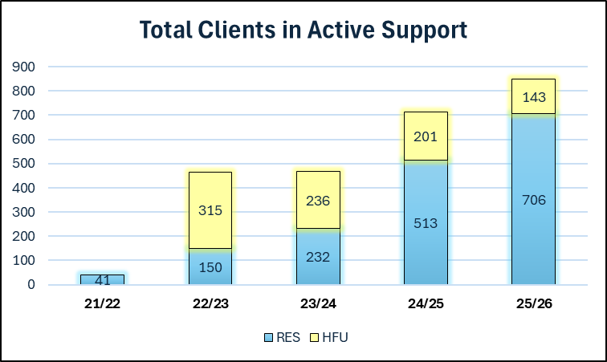Res = Resettlement; HFU = Homes for Ukraine
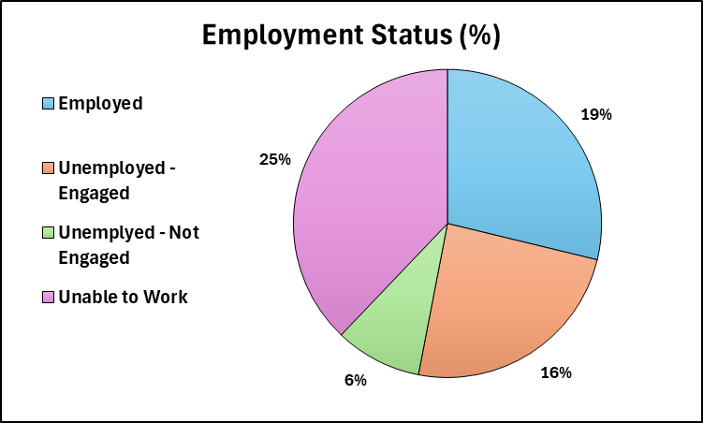
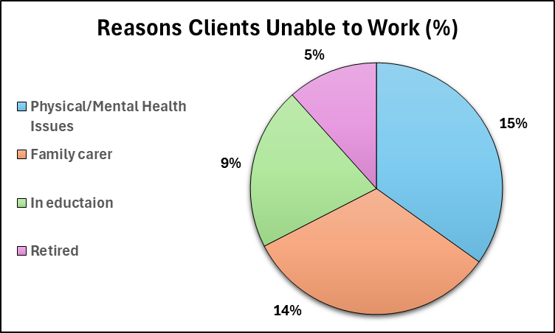
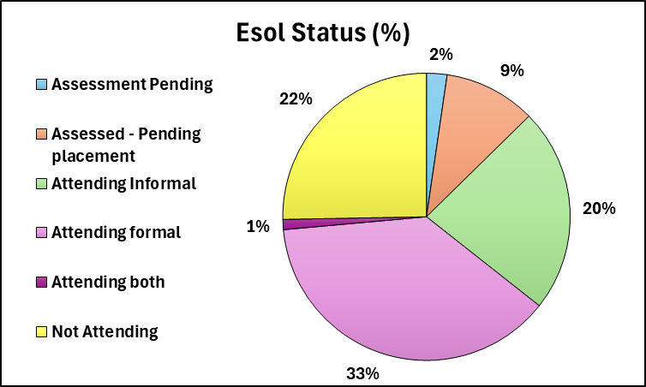
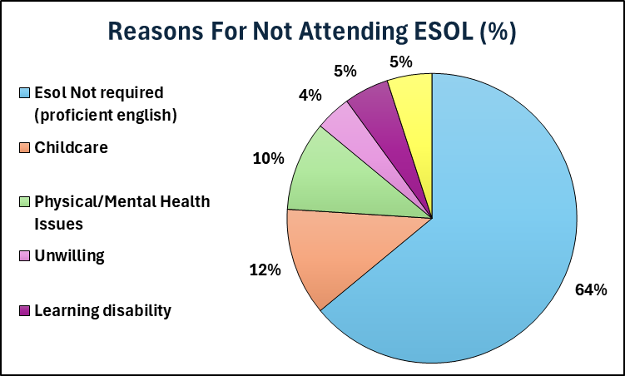

Appendix 02
This document was provided by the Resettlement Team at Islington Council and is an overview of the services under the NRPF, Refugee and Migrant Service as of November 2025.

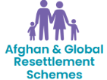
Since 2015, Islington Council has actively participated in government funded refugee resettlement schemes, in which some people have been identified as highly vulnerable, by the United Nations High Commissioner for Refugees. Across London, Islington is spearheading an exemplary, high-quality integration programme, delivering services to Afghan refugees and refugees from other countries. This work includes casework and housing support, education and employment, health and wellbeing, enabling those fleeing war and conflict to become independent and economically self-sufficient.
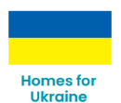
Islington Council is proud to be part of the national Homes for Ukraine Scheme*, a vital initiative that has enabled Islington residents to open their homes to Ukrainian nationals fleeing the war. This community-led sponsorship scheme, launched by the Government in March 2022, has welcomed hundreds of Ukrainian nationals to Islington, offering them a chance to rebuild their lives while living here temporarily. We work closely with both Ukrainian nationals and our Islington-based hosts, ensuring that everyone involved receives the guidance, support and resources they need.
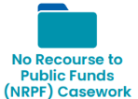
Our NRPF service provides a vital safety-net to adults with care and support needs, as well as families, who cannot access local authority housing and benefits due to their immigration status and are destitute or at risk of homelessness. Working with Adult and Children Social Care, our NRPF team provides: 1) Accommodation and subsistence for households with NRPF; 2) Expertise around immigration-specific needs; 3) Guidance to all relevant professionals around the rights and entitlements of our residents. Our NRPF team use their expertise to drive up standards for migrants in need and create a cost-effective service for the Council. This work started in the late 1990s and is local authority funded.
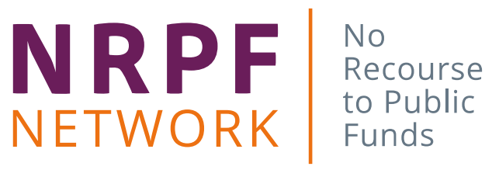
Islington has proudly hosted the NRPF Network since it was established in 2006. Reporting to a UK-wide steering group, and working with a wide range of stakeholders, the Network assists councils across the UK to deliver effective ‘safety-net’ support when residents with no recourse to public funds are at risk of destitution by: Providing expert advice, training, and practice guidance; Facilitating partnership working between more than 90 councils and Home Office caseworkers through NRPF Connect, leading to faster case resolution and cost savings for councils; Enabling councils to access the Recourse to Public Funds checker following the roll out of e-Visas; Providing a collective local government voice at a strategic policy level; Evidencing the need for funding for councils and national policy change to reduce homelessness, child poverty and inequalities The NRPF Network generates income to cover its operating costs.
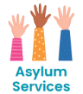
We support adults who are often fleeing persecution in their own country or caught up in war and are awaiting a decision on their asylum claim in the UK. These residents typically have no right to work or receive benefits and live in very basic accommodation with ongoing uncertainty, often without family or connections. Our caseworkers help these residents gain equitable access to statutory services and provide advice and guidance. We build partnerships and fund local services to help improve these residents’ wellbeing.
Children Seeking Sanctuary - Islington Council is proud to welcome and support children and young people who arrive in the borough without parents or carers. They are often victims of being displaced from their homes, may have lost family members due to living in war and conflict or they could be escaping being trafficked or enslaved. The Council commissions local organisations to deliver services to these young residents to help these young people feel part of our community and develop the knowledge and skills they need for their future life.
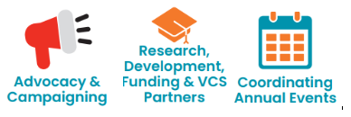
Working closely with our lead Councillors, Migrant Champions, VCS communities and the NRPF Network, we raise national policy concerns with Government and advocate for improved asylum and immigration practices, to stem poverty and homelessness. We also ensure residents’ voices are being heard by Government and are proud of policy changes we have successfully influenced. While campaigning, we continue to provide advice and expert testimony to Government departments, including those who fund us. We undertake research with partners including universities and those with lived experience who, co-design and co-deliver with us, helping us ensure continued service improvements. We manage events noting days of importance to our communities. Our events bring together our clients, colleagues and partners in an atmosphere of community solidarity and celebration.
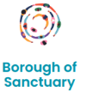
Islington is officially a Borough of Sanctuary, recognised for its commitment to welcoming and supporting refugees, migrants, and people seeking asylum. Our status acknowledges our borough’s long history of migration, its diversity, and the Council’s ongoing work to create a welcoming place for all, regardless of one’s country of origin or immigration status. Being a Borough of Sanctuary means we can take political, service and community-based actions, allowing us to better meet the needs of our residents from migrant, refugee and asylum-seeking backgrounds while strengthening connections between communities.

Appendix 03
Internal partners and commissioned providers
Partner | Service provided | Council/External
Adult Community Learning (ACL) | Designs and delivers bespoke ESOL classes at different levels with childcare. | Council service
Income Maximisation (IMAX) | Supports with accessing benefits, maximising household income and dealing with debt. | Council service
IWORK | Provides tailored employment support and training on accessing the labour market. | Council service
Traumatic Stress Clinic – St Pancras Hospital | Supports mental wellbeing with adult assessments, group work, onward referrals and Post Traumatic Stress Disorder (PTSD) therapy. | NHS provider
Respond – University College London Hospitals | An integrated health service for people of all ages seeking asylum and refugees.  Supports with health assessments and onward referrals to health services. | NHS provider
Kurdish and Middle EasternWomen Organisation (KMEWO) | Delivers community, social and cultural group and individual support focussing mainly on women and young girls. | Voluntary Community Sector
Ramfel | Charity that supports vulnerable migrants to access justice. Commissioned for immigration representation for resettled refugees, people with no recourse to public funds and people seeking asylum. | Charity
All Change | Charity commissioned for arts and cultural group activities. | Voluntary Community Sector

Appendix 04
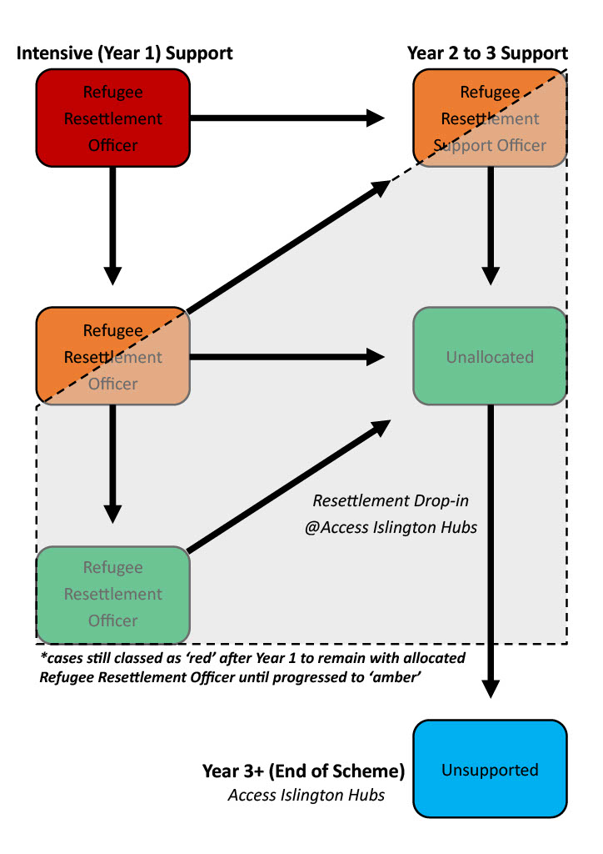

Appendix 05
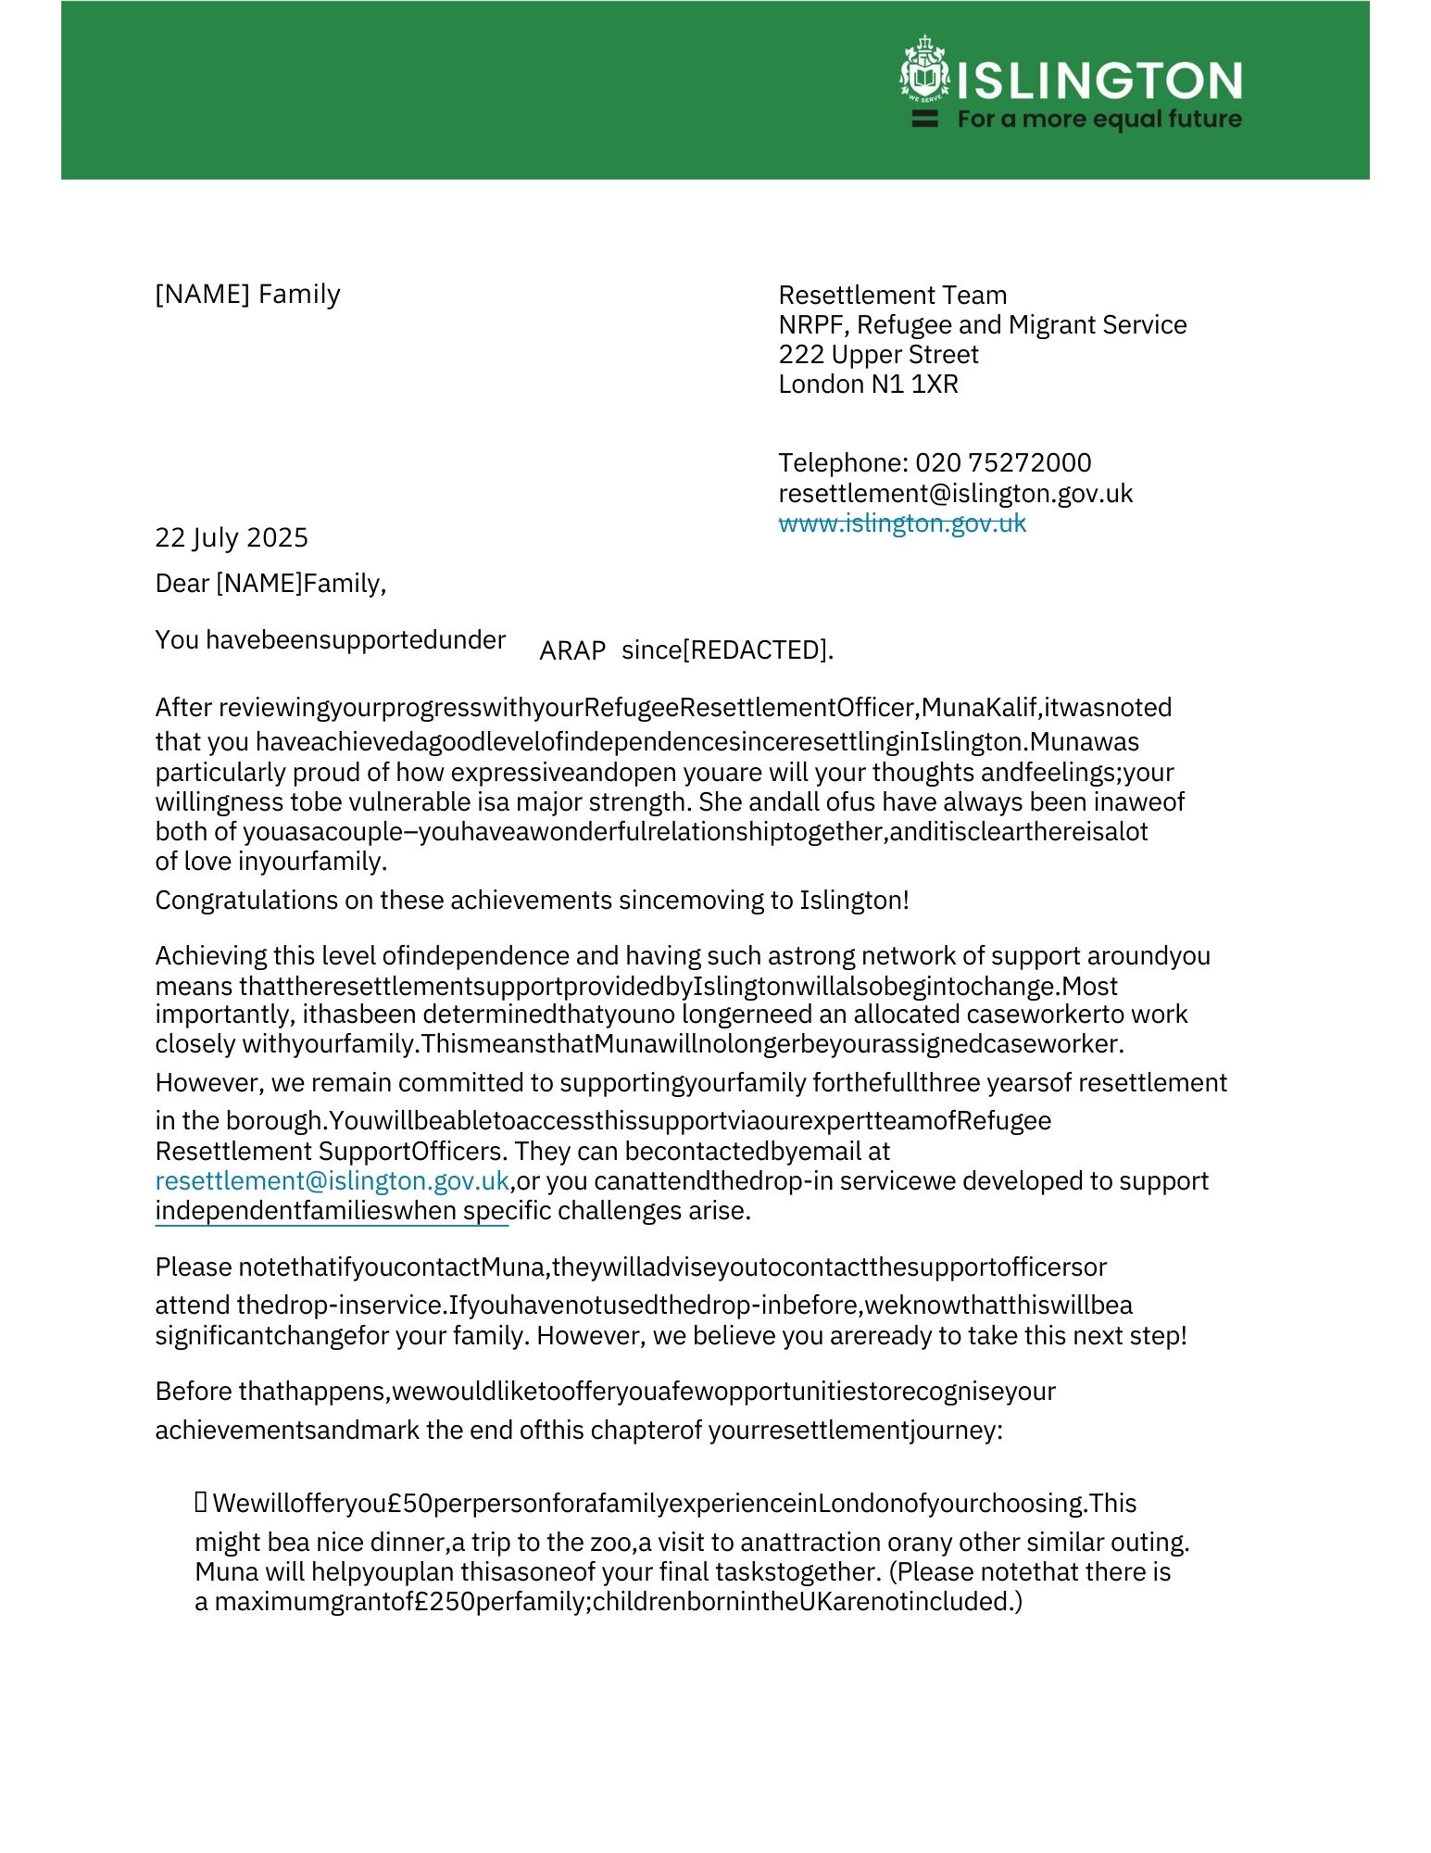
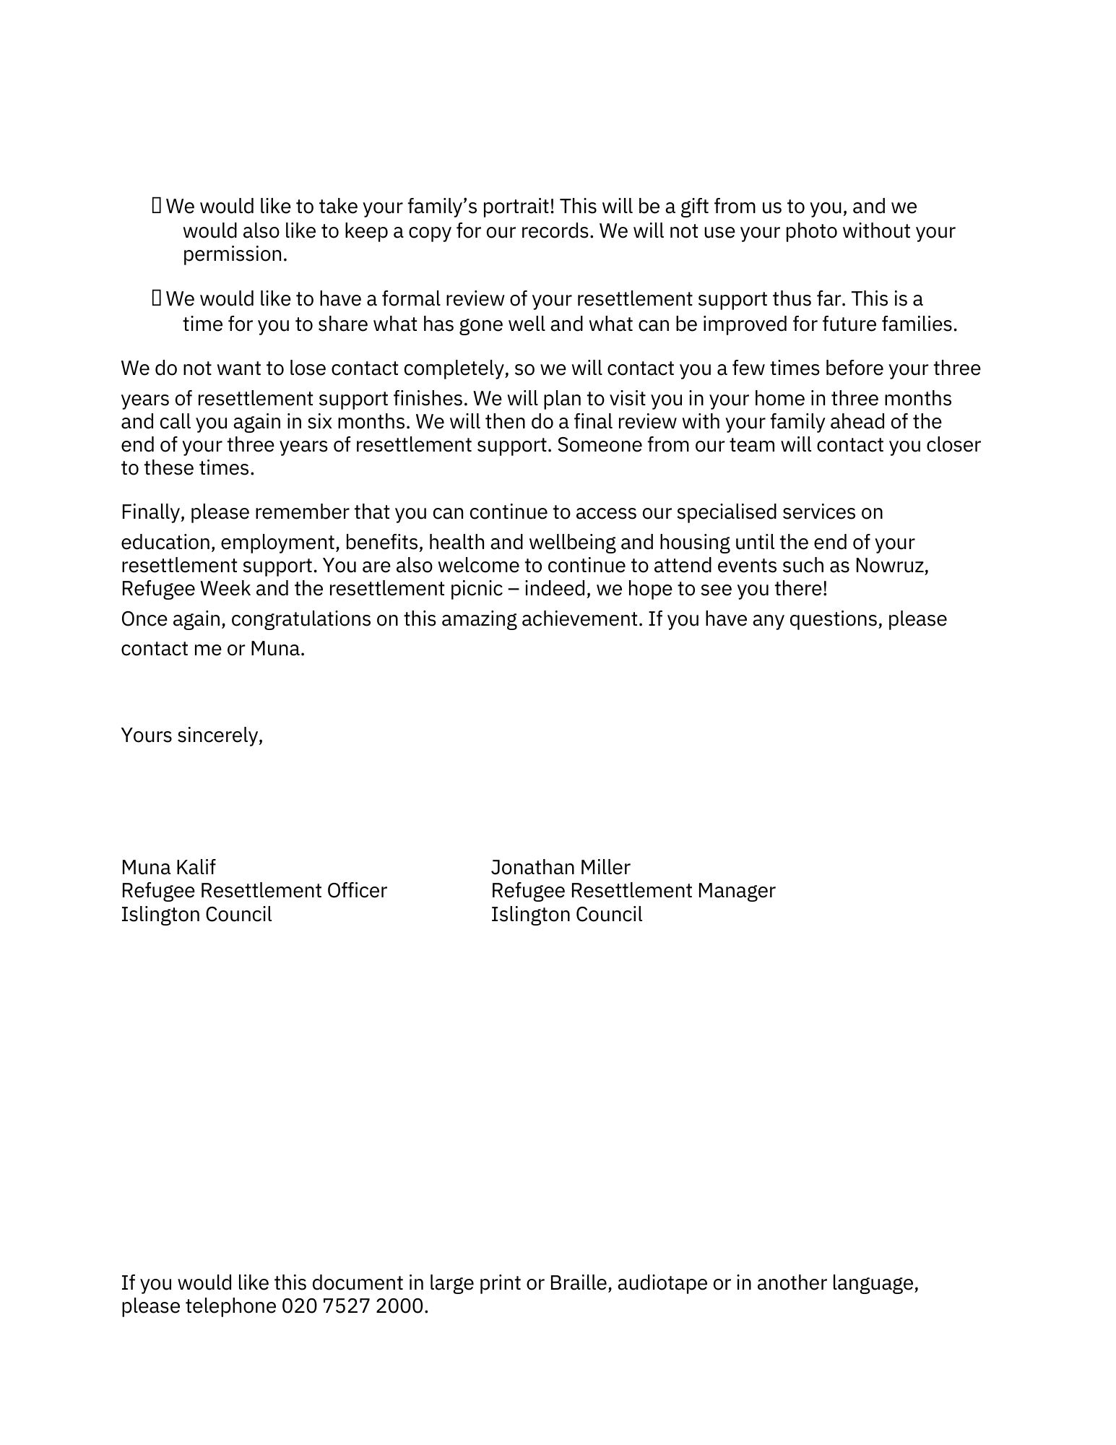
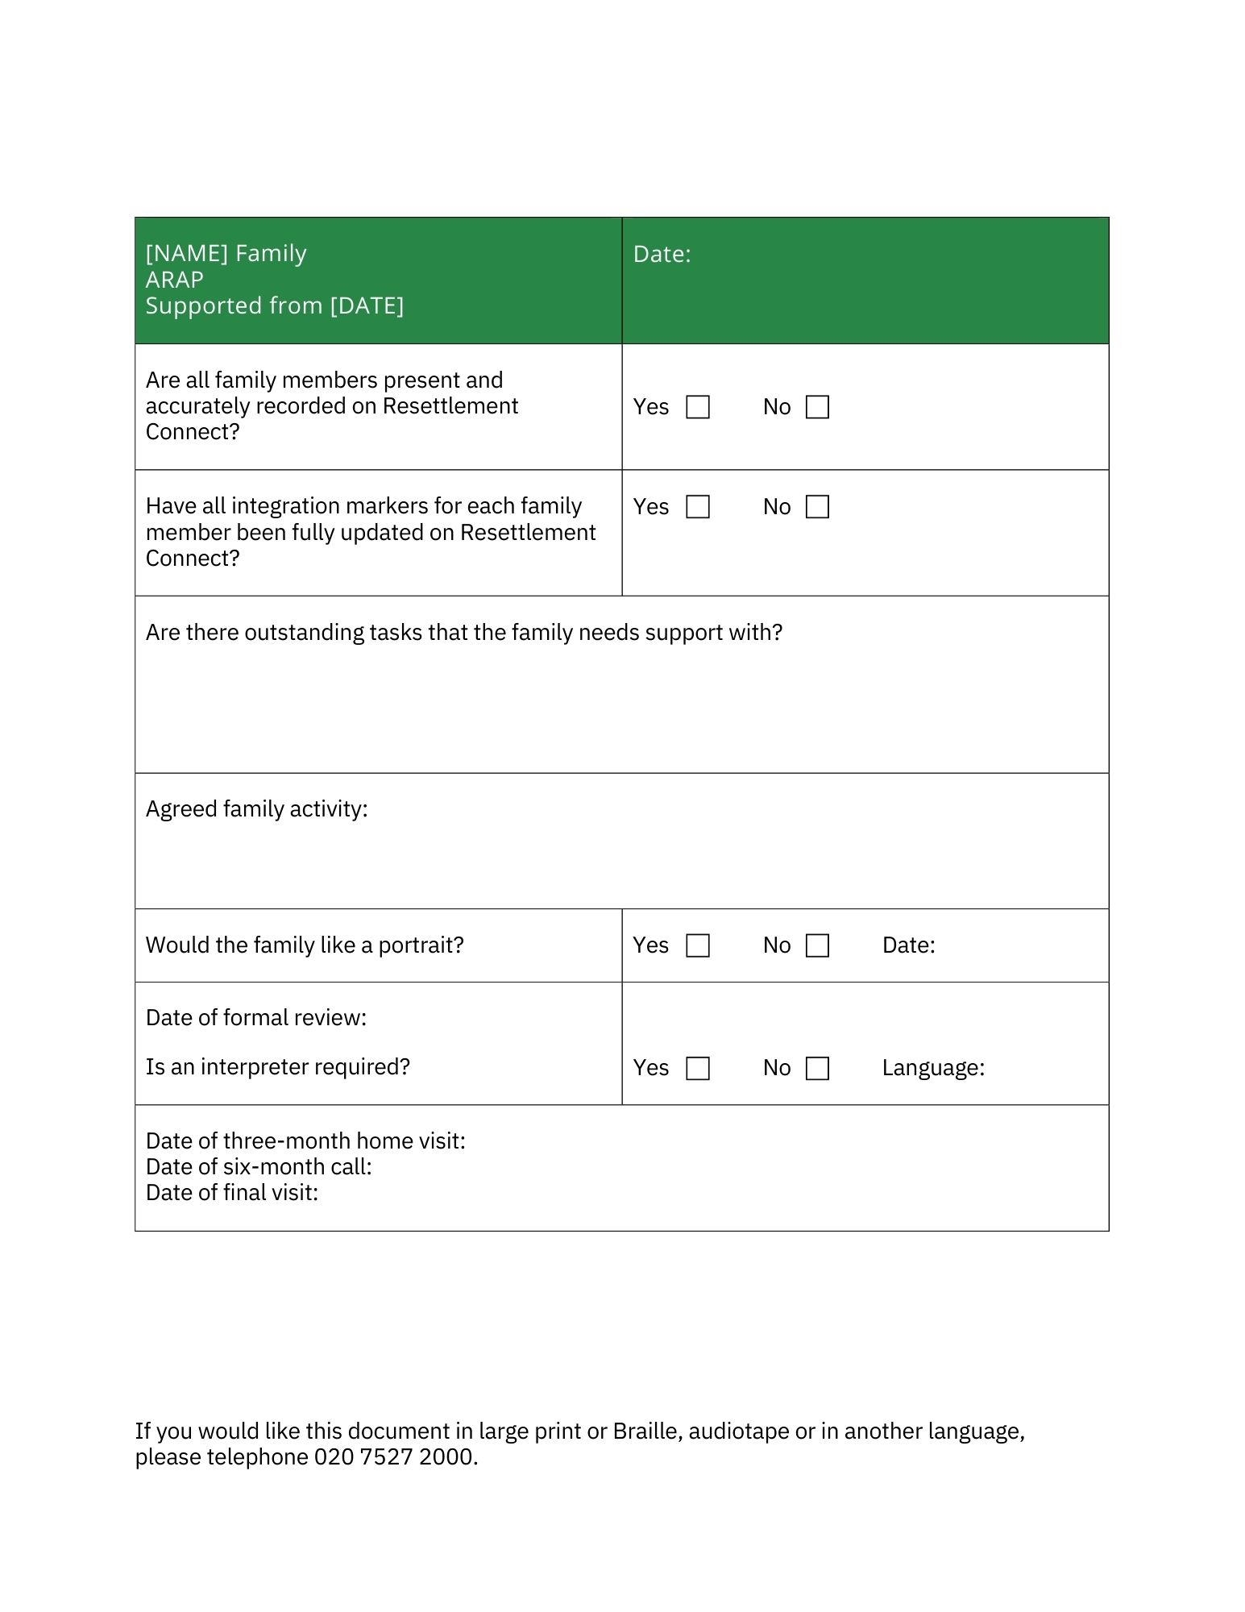

Appendix 06
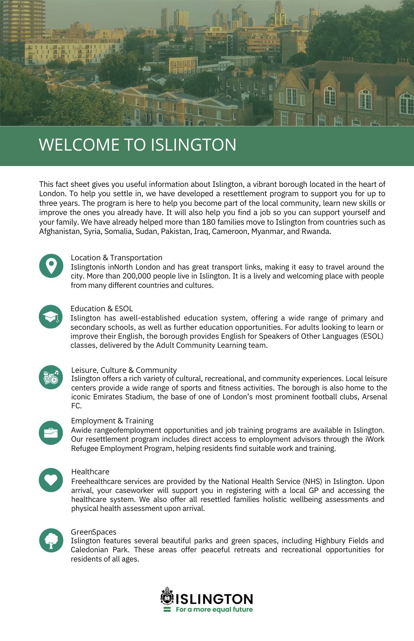

These included general ARAP and ACRS applications processes and potential for family reunion.
See https://commonslibrary.parliament.uk/research-briefings/cbp-9428/ on rising cost of living and https://commonslibrary.parliament.uk/research-briefings/cbp-9714/ on energy crisis.
https://www.pbs.org/wgbh/frontline/article/syrian-war-human-toll-deaths-disappearances-mass-graves-displacement/
https://scm.bz/wp-content/uploads/2024/03/Monthly_Stat_Rep_Feb2024_EN.pdf
https://www.unrefugees.org/news/syria-refugee-crisis-explained/
https://www.unrefugees.org/refugee-facts/statistics/
https://www.unrefugees.org/news/afghanistan-refugee-crisis-explained/
Ibid.
https://www.refugeecouncil.org.uk/information/refugee-asylum-facts/refugee-resettlement-facts/
https://www.gov.uk/government/publications/uk-resettlement-schemes-factsheet-march-2021/vulnerable-persons-and-vulnerable-childrens-resettlement-schemes-factsheet-march-2021
ibid
ibid
https://www.gov.uk/government/publications/afghan-resettlement-programme-operational-data/afghan-resettlement-programme-operational-data
https://www.gov.uk/guidance/afghan-resettlement-programme
The ARR was created as a response to a data breach in February 2022 and was discontinued in July 2025. See https://www.gov.uk/guidance/afghanistan-response-route
https://www.gov.uk/government/publications/afghan-resettlement-programme-operational-data/afghan-resettlement-programme-operational-data
Ibid.
https://www.islington.gov.uk/advice/support-non-uk-nationals/refugee-resettlement
Given the size of the sample, and its targeted nature, no quantitative analysis of demographic data is hereby provided to preserve anonymity.
See Appendix 06 for a sample leaflet provided to newly resettled people.
https://outcomesstar.org/
https://resettlementconnect.org/
The Council noted that Research and Structure were created before Resettlement Connect so not all sections match the integration markers they now track.
English schools face significant challenges, including workforce shortages and stretched budgets due to falling pupil numbers and widening attainment gaps among disadvantaged pupils. These issues impact finances and hinder the government's efforts to meet its education goals, particularly with regard to children with special educational needs and disabilities (SEND) and those from low-income backgrounds (Institute for Government 2025).
These included general ARAP and ACRS applications processes and potential family reunion.
The Bell Foundation. 2024. ESOL Qualifications and Curriculum Review. Available at: https://www.bell-foundation.org.uk/app/uploads/2025/07/ESOL-Qualifications-and-Curriculum-Review-report_FV-updated.pdf?_gl=1*12oetvs*_up*MQ..*_ga*MTU4MDU5ODU1NS4xNzU4ODgxODcw*_ga_QBGWH5CZBF*czE3NTg4ODE4NjkkbzEkZzAkdDE3NTg4ODE4NjkkajYwJGwwJGgw
This government policy has now changed.
It is important to note that a proportion of the LAHF properties was purchased with MHCLG funding specifically to accommodate large Afghan families resettled by the UK Government.
While the man hoped to buy his own property one day, the LAHF flats are owned by the council, let at 80% market rent on a long-term basis without the option of being purchased by tenants.
See https://commonslibrary.parliament.uk/research-briefings/cbp-9428/ on rising cost of living and https://commonslibrary.parliament.uk/research-briefings/cbp-9714/ on energy crisis.
See wider academic research on this topic by Cheung, S. Y., & Phillimore, J. (2014). Refugees, social capital, and labour market integration in the UK. Sociology, 48(3), 518-536.
For more discussion of this challenge see: Ryan, L., López, M., Dalceggio, A., & Adell, F. (2025). ‘You Need a Network’: How Highly Skilled Refugees Build Social Networks to Convert Cultural Capital and Reclaim Professional Identities. Sociology, 00380385251363897.
As a team we were saddened by the death of Afghan 14 and wish to express our condolences to his family.
The UK secondary educational system is notoriously complex with multiple different qualification routes and pathways which can be confusing for many British parents and their teenage children to navigate. See Hodgson, A., & Spours, K. (2020). Young People and Transitions in Upper Secondary Education in England. In Youth on the Move, (edited by Brunila & Lundahl) Helsinki University Press. Available at: https://library.oapen.org/bitstream/id/237f8b78-c6cc-4c6d-be7f-416b0de450ac/youth-on-the-move.pdf
For more detailed analysis of the role of social networks for migrants and refugees see Ryan, L. (2024) Social Networks and Migration: relocations, relationships and resources. Bristol University Press. https://bristoluniversitypress.co.uk/social-networks-and-migration
Separated Families pathway for Afghans under ACRS Pathway 1 who were separated from their immediate family (including children under 18) during the 2021 evacuation.
For similar findings in a research project with Syrian refugees in the North of England see Speed, F., Scurry, T., Edward, P., & Moufahim, M. (2021). Networks amongst Syrians: Situated migrant positionalities and the impact on relational embedding. Social Inclusion, 9(4), 243-253.
Our Afghan and Global Resettlement and Homes for Ukraine Schemes use government funding which can only be used to deliver services to these client groups.

